Pictures:

lecture 65 onwards, till now we have done all the steps before the sta analysis and now we will repleae the cells with those of higher drive strength so that we can reduce the deley

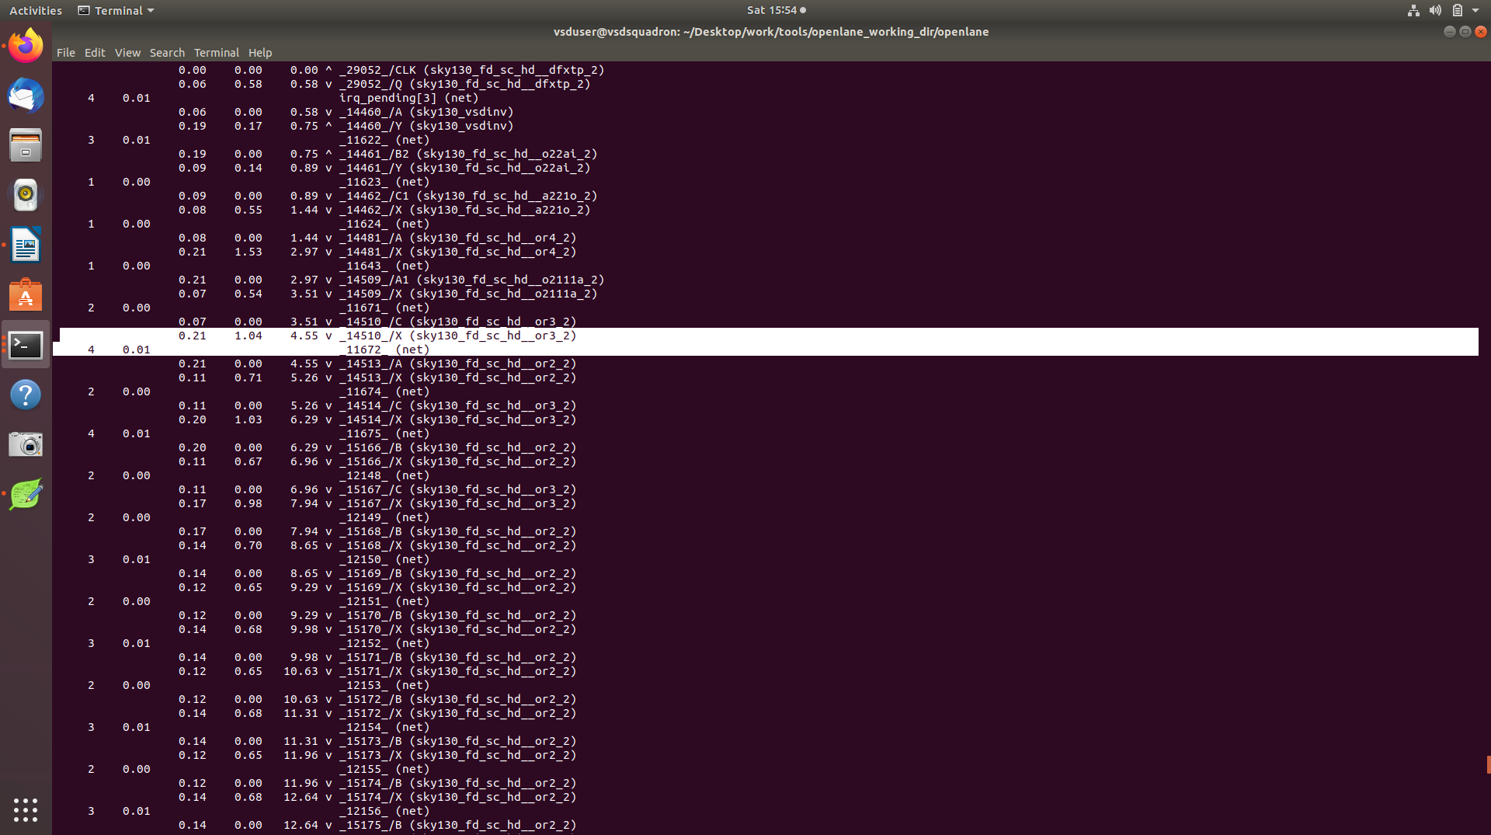
the or gate that we are going to replace with higher drive strength one as it has 4 as fanout but less drive strength

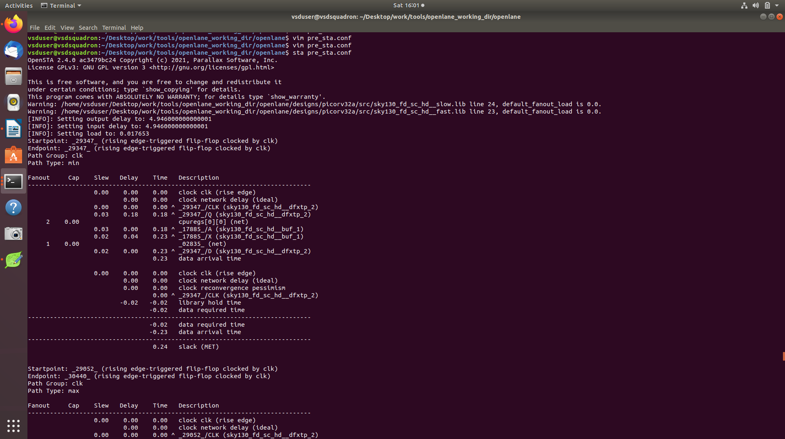
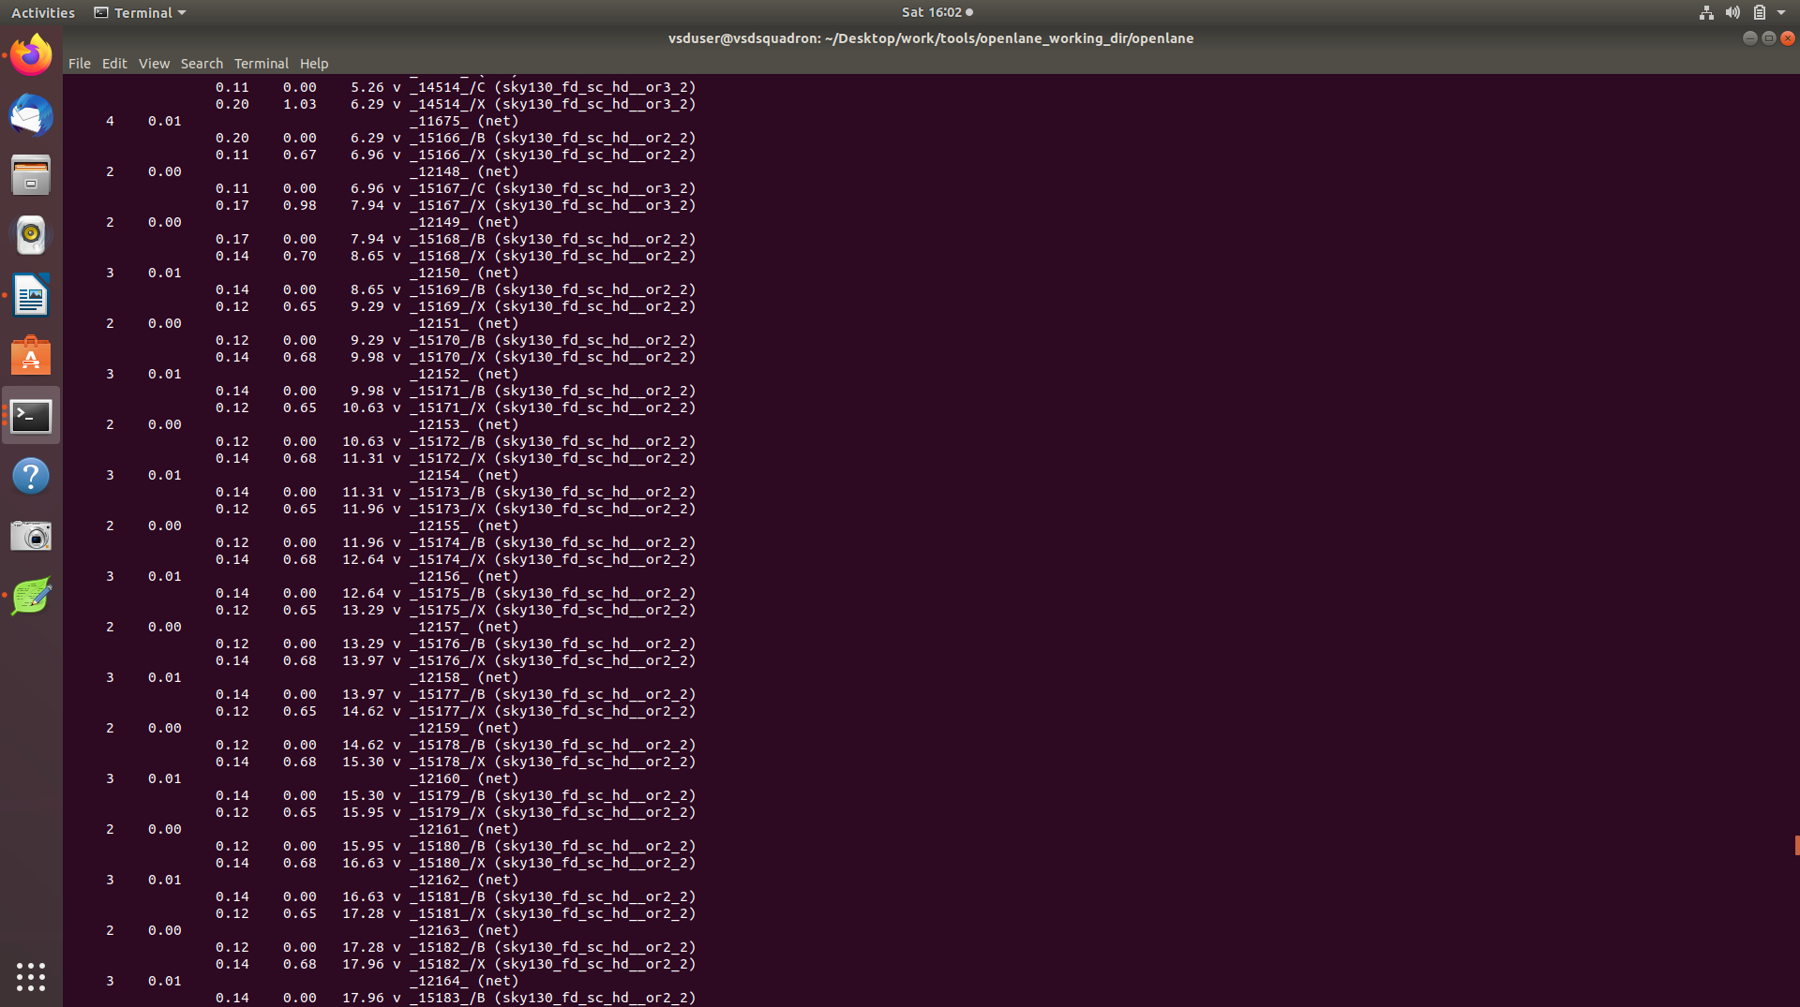
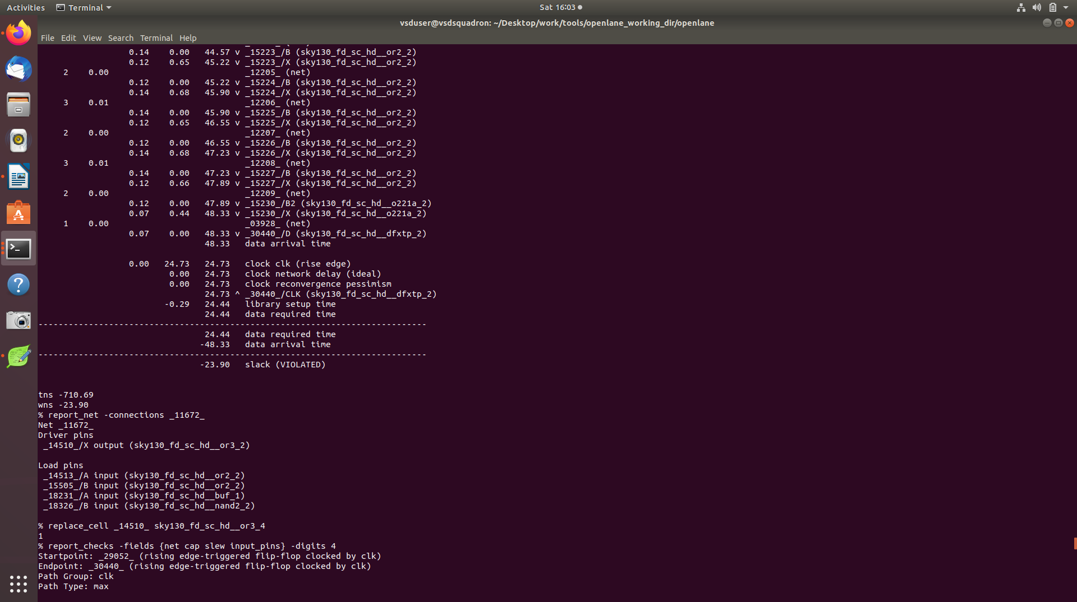
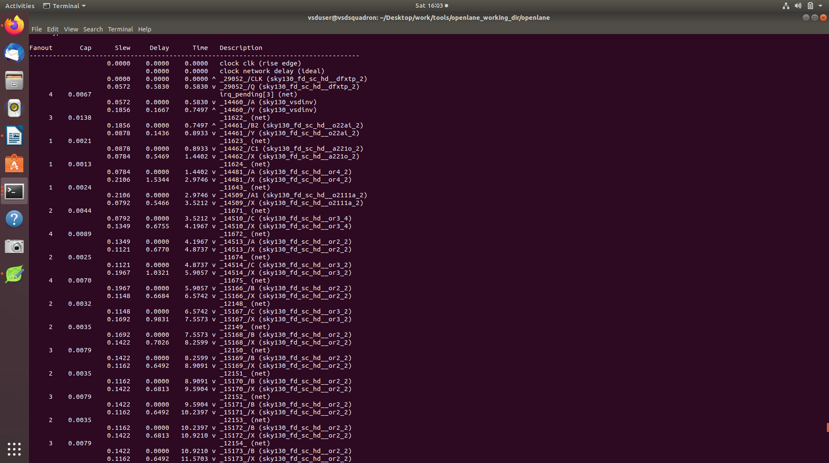
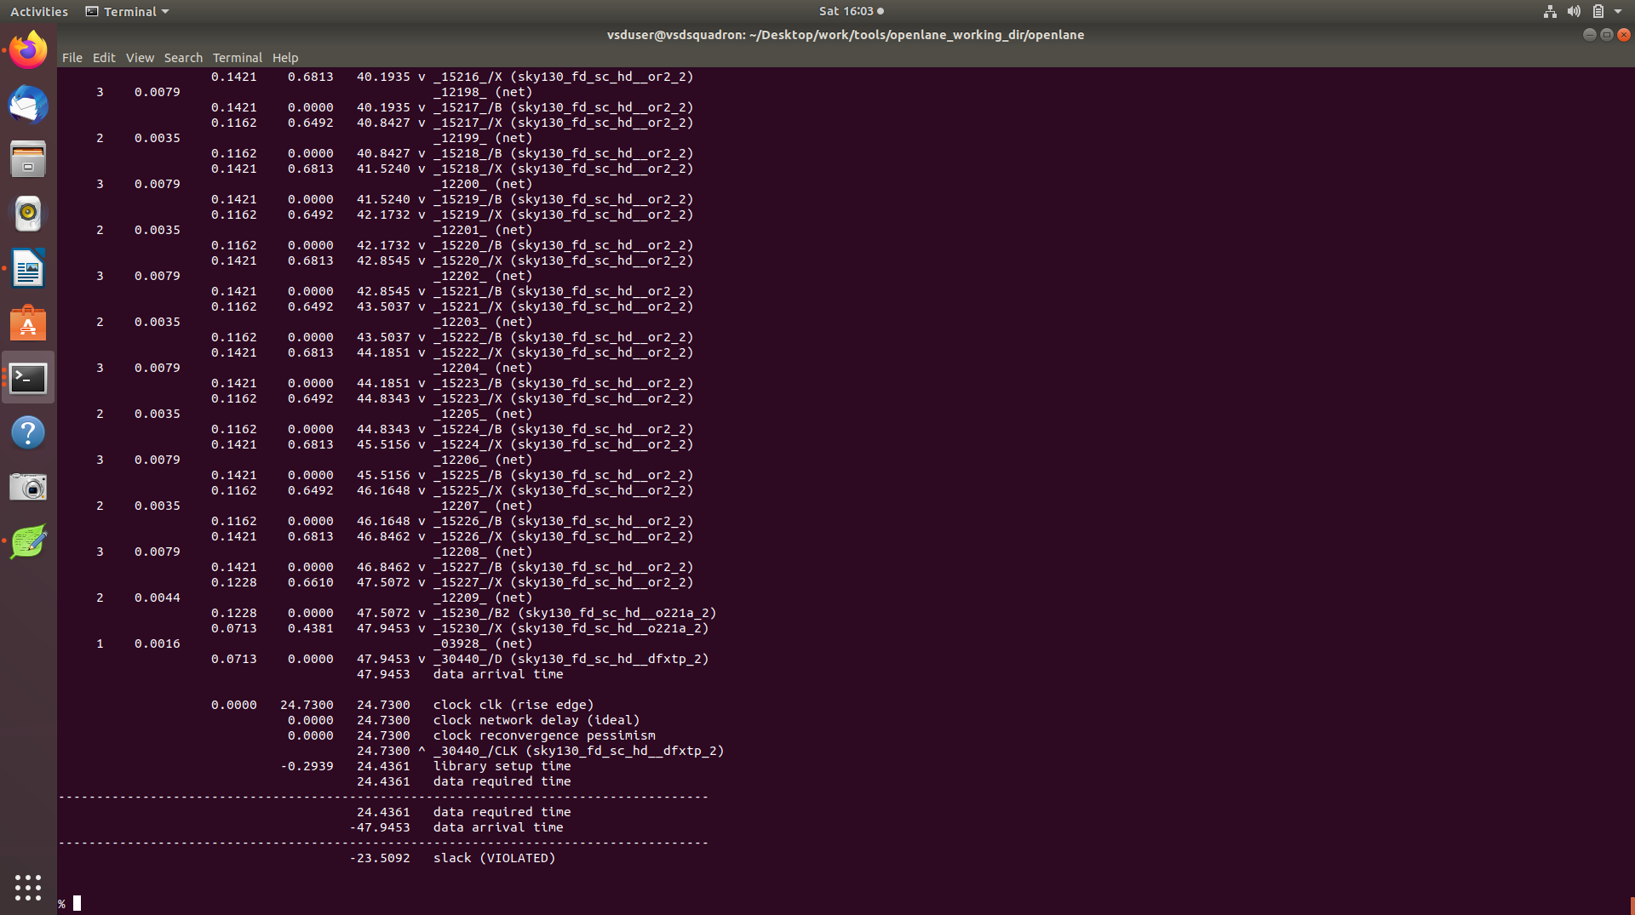
clearly the slew improved from -23.9 to -23.5

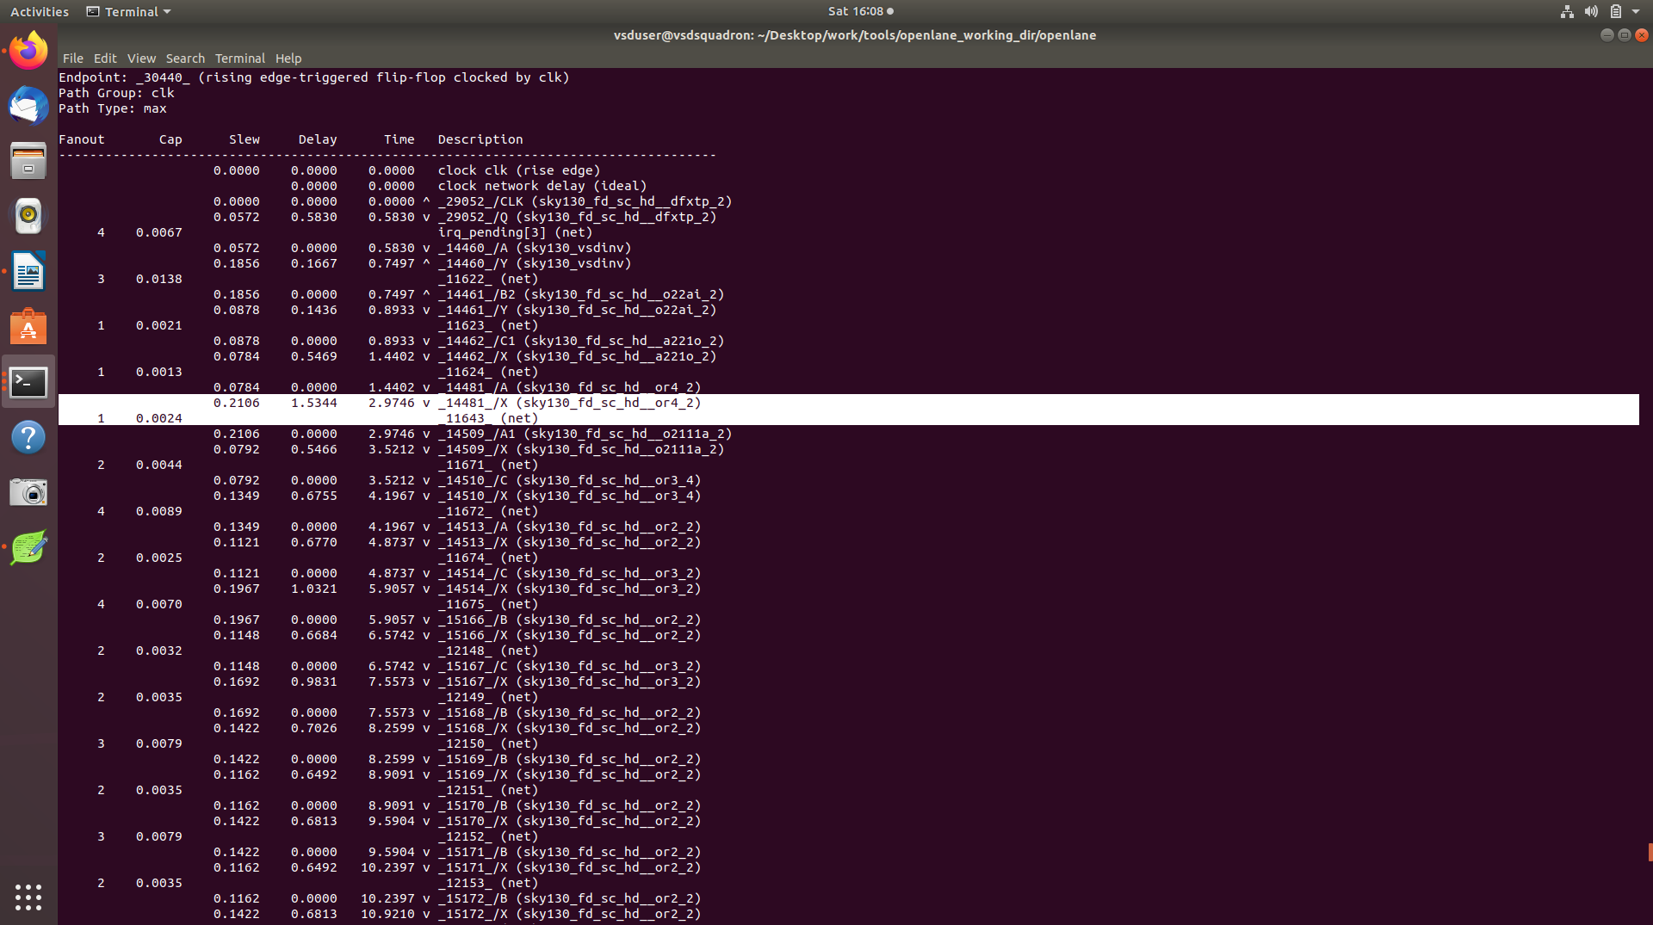
this is the second OR gate that has significant delay and we will replace it with higher drive strength

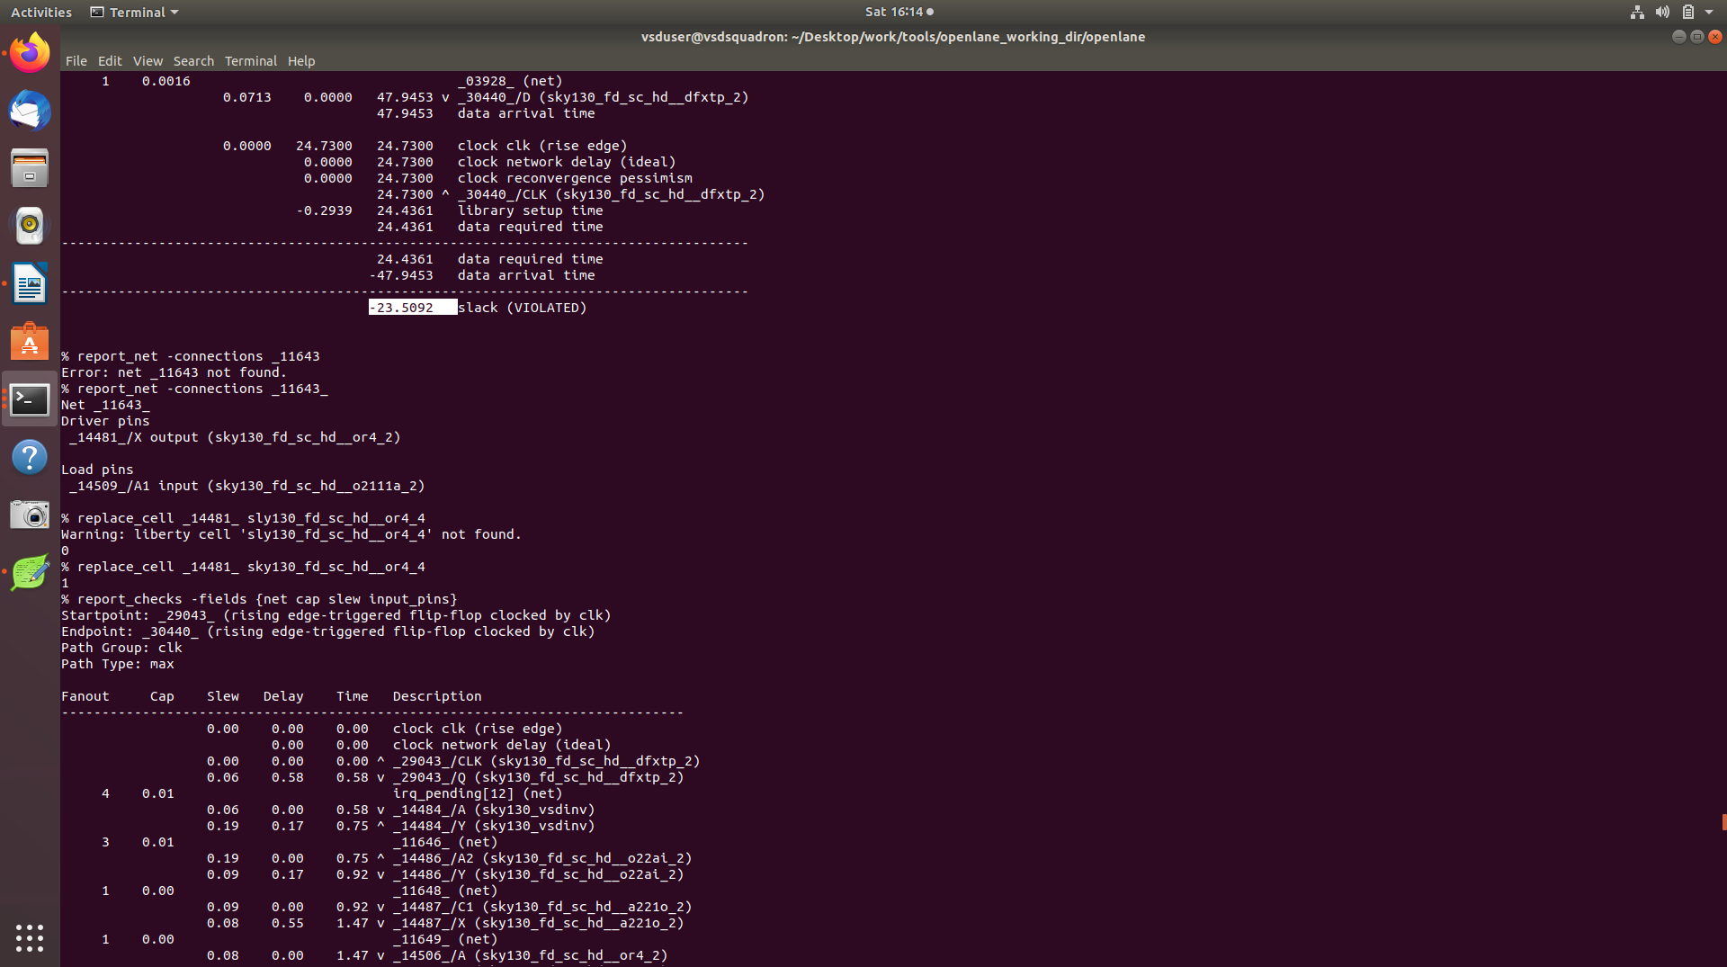
replacing the next cell, but rerun the analysis I forgot to put digits argument

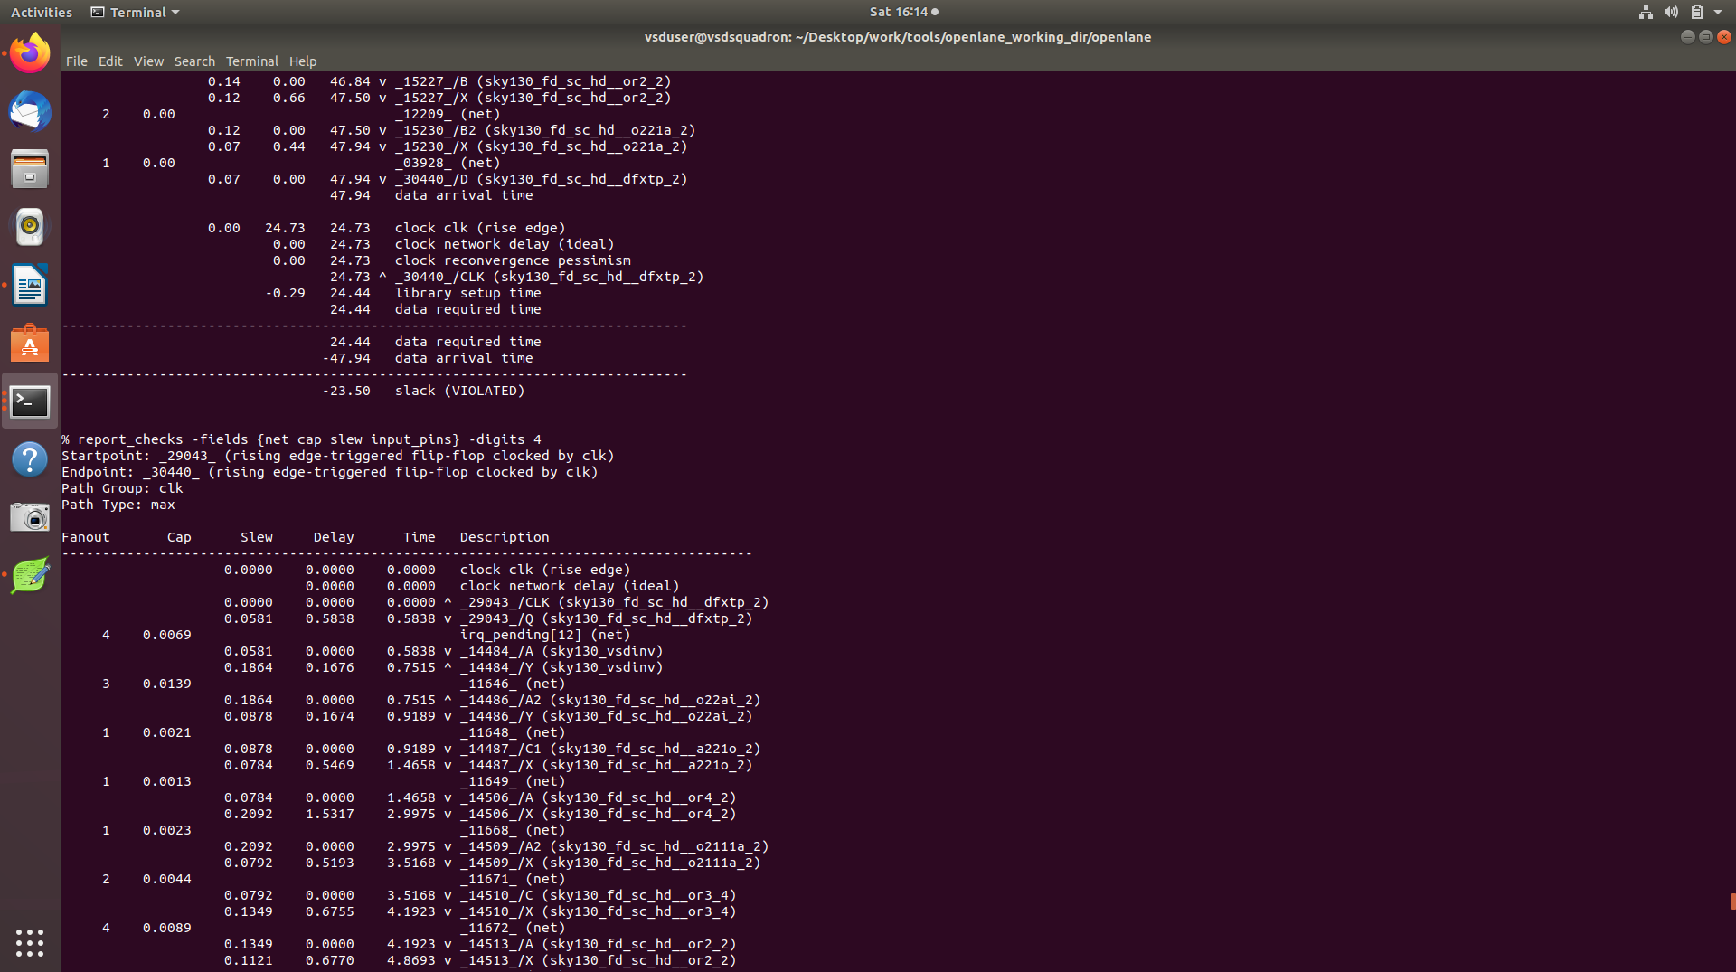
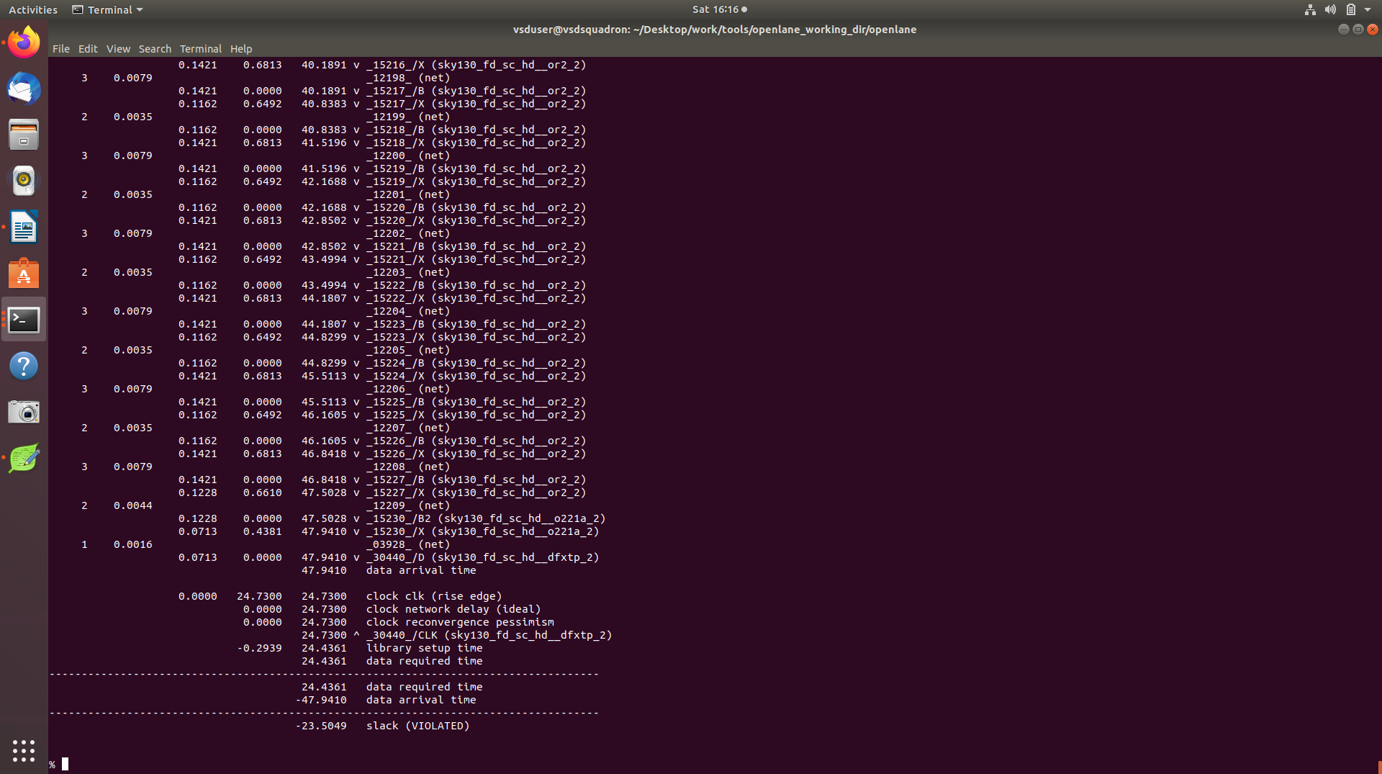
cleary slew reducsed to -23.5049 from -23.5092

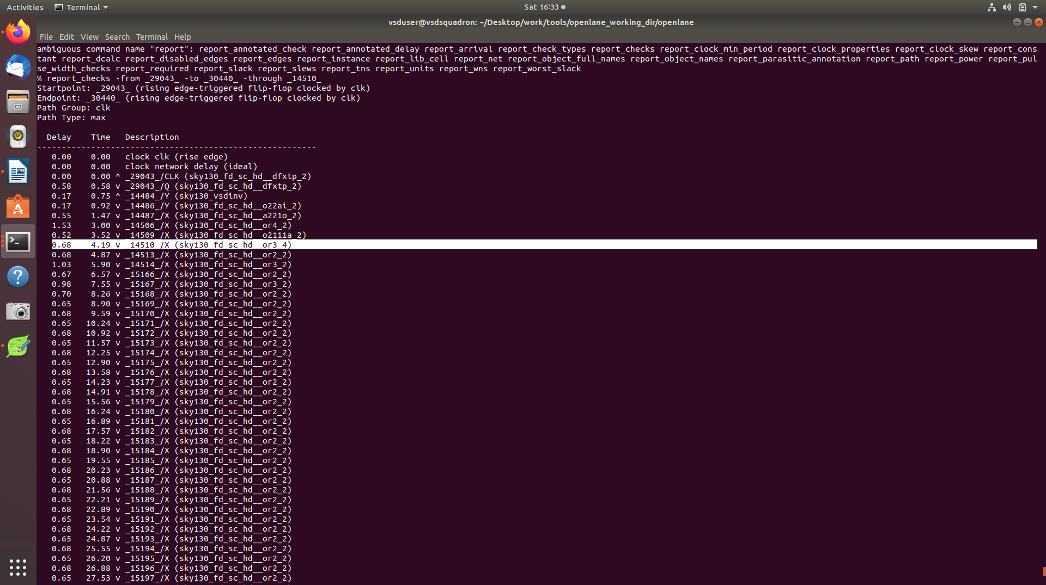
screenshot of the replaced cell 14510 with the new cell of higher drive strength

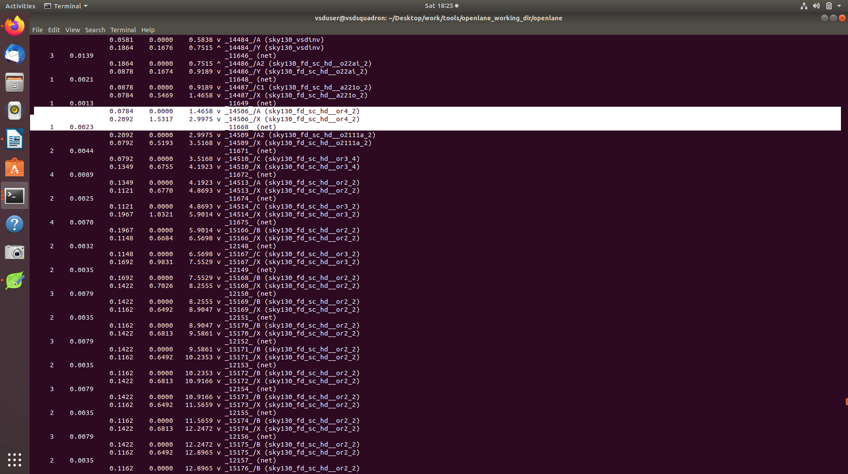
another OR gate with excessive delay, replacing it with or4_4

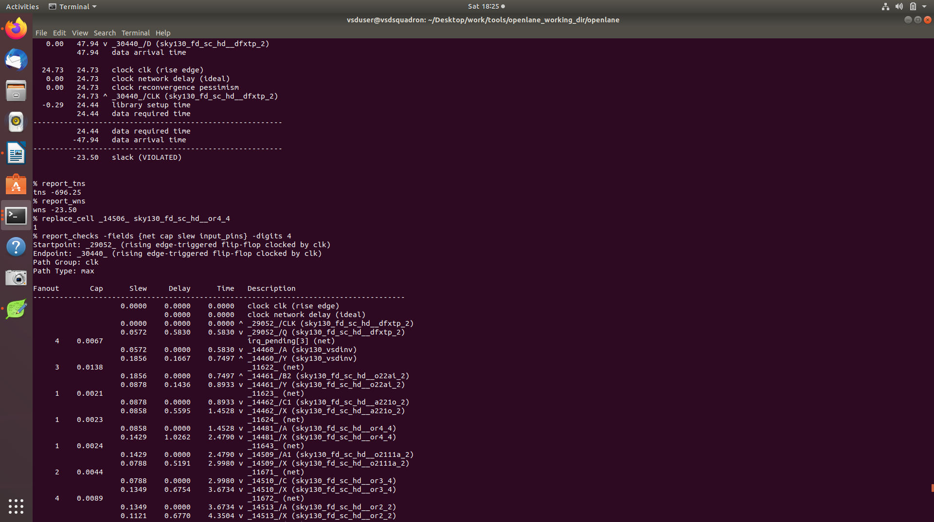
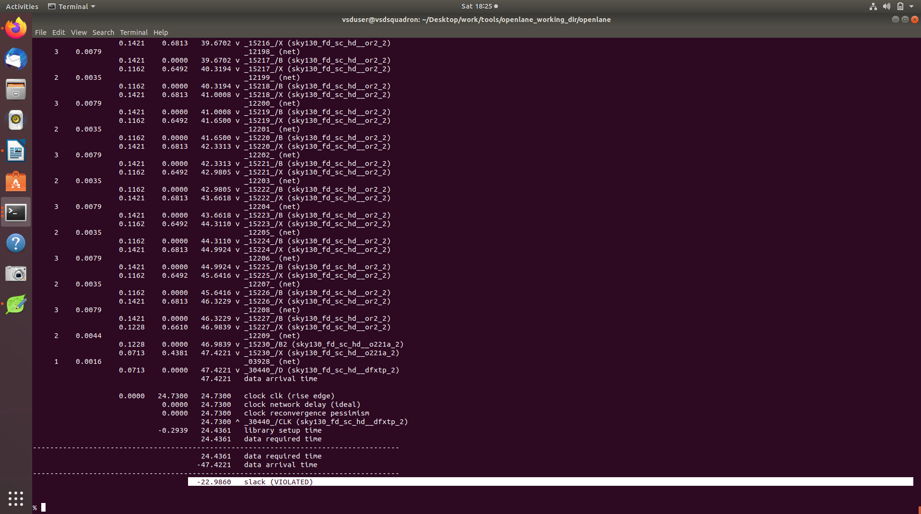

slew has further reduced from -23.5049 to -22.9860

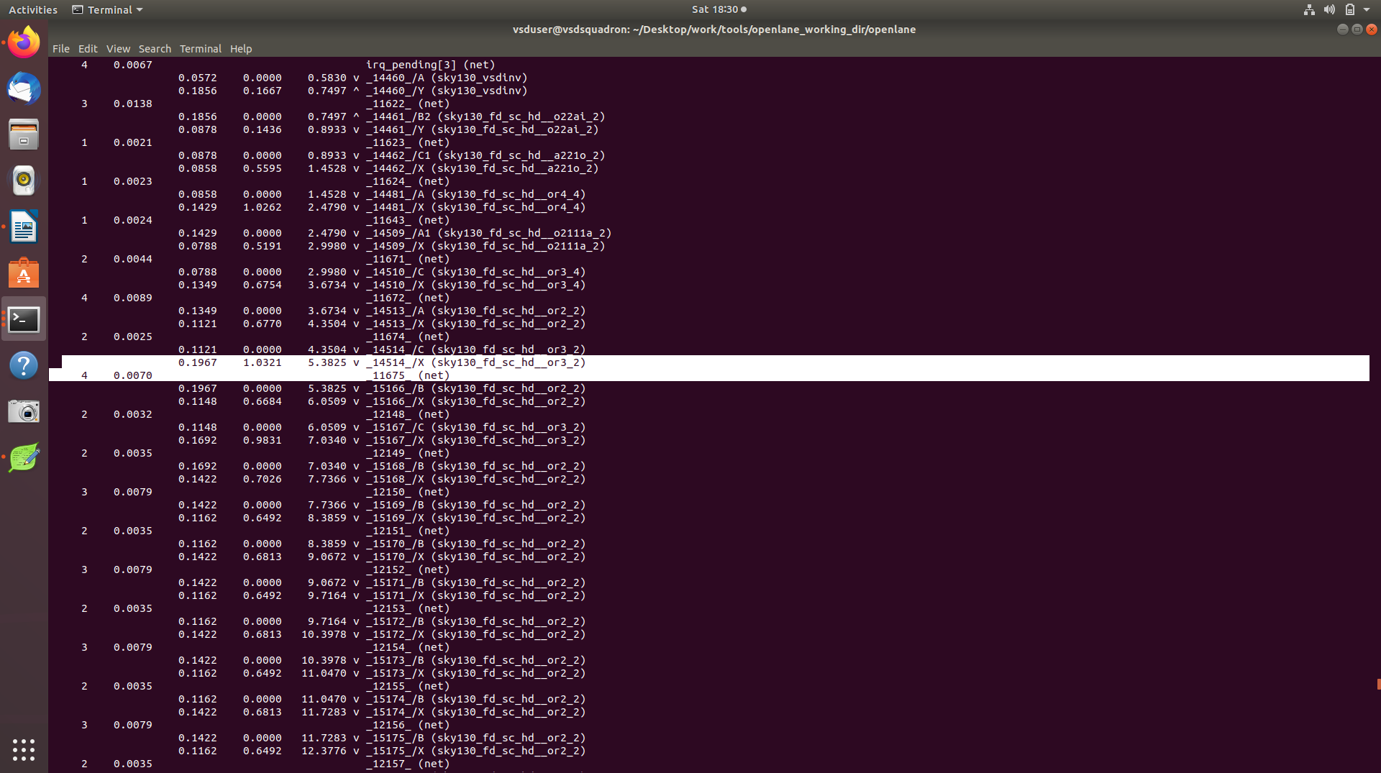
replacing another delayed OR gate with upsized gate

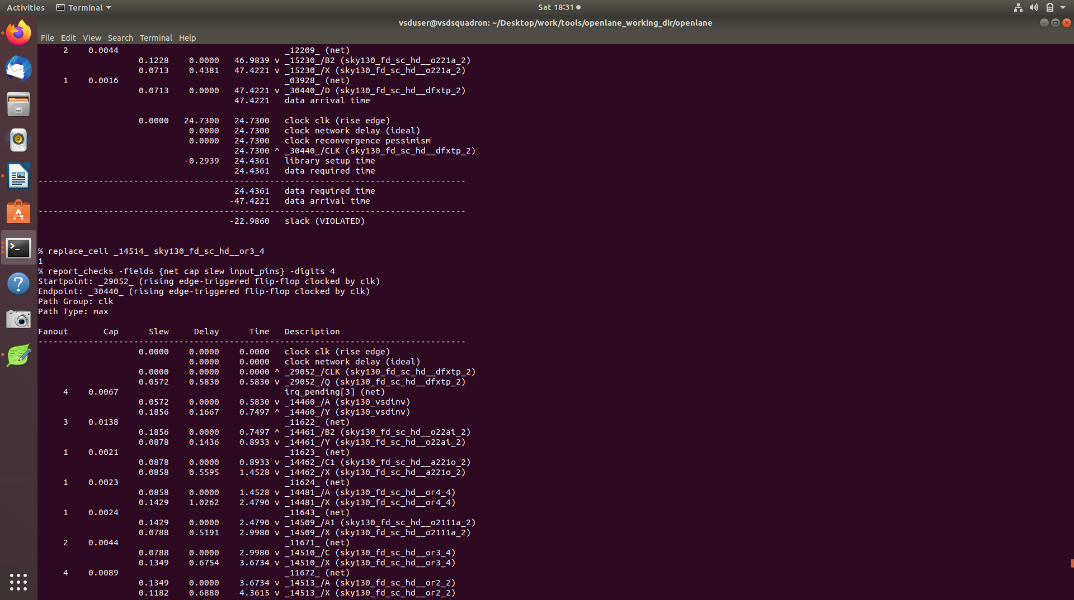

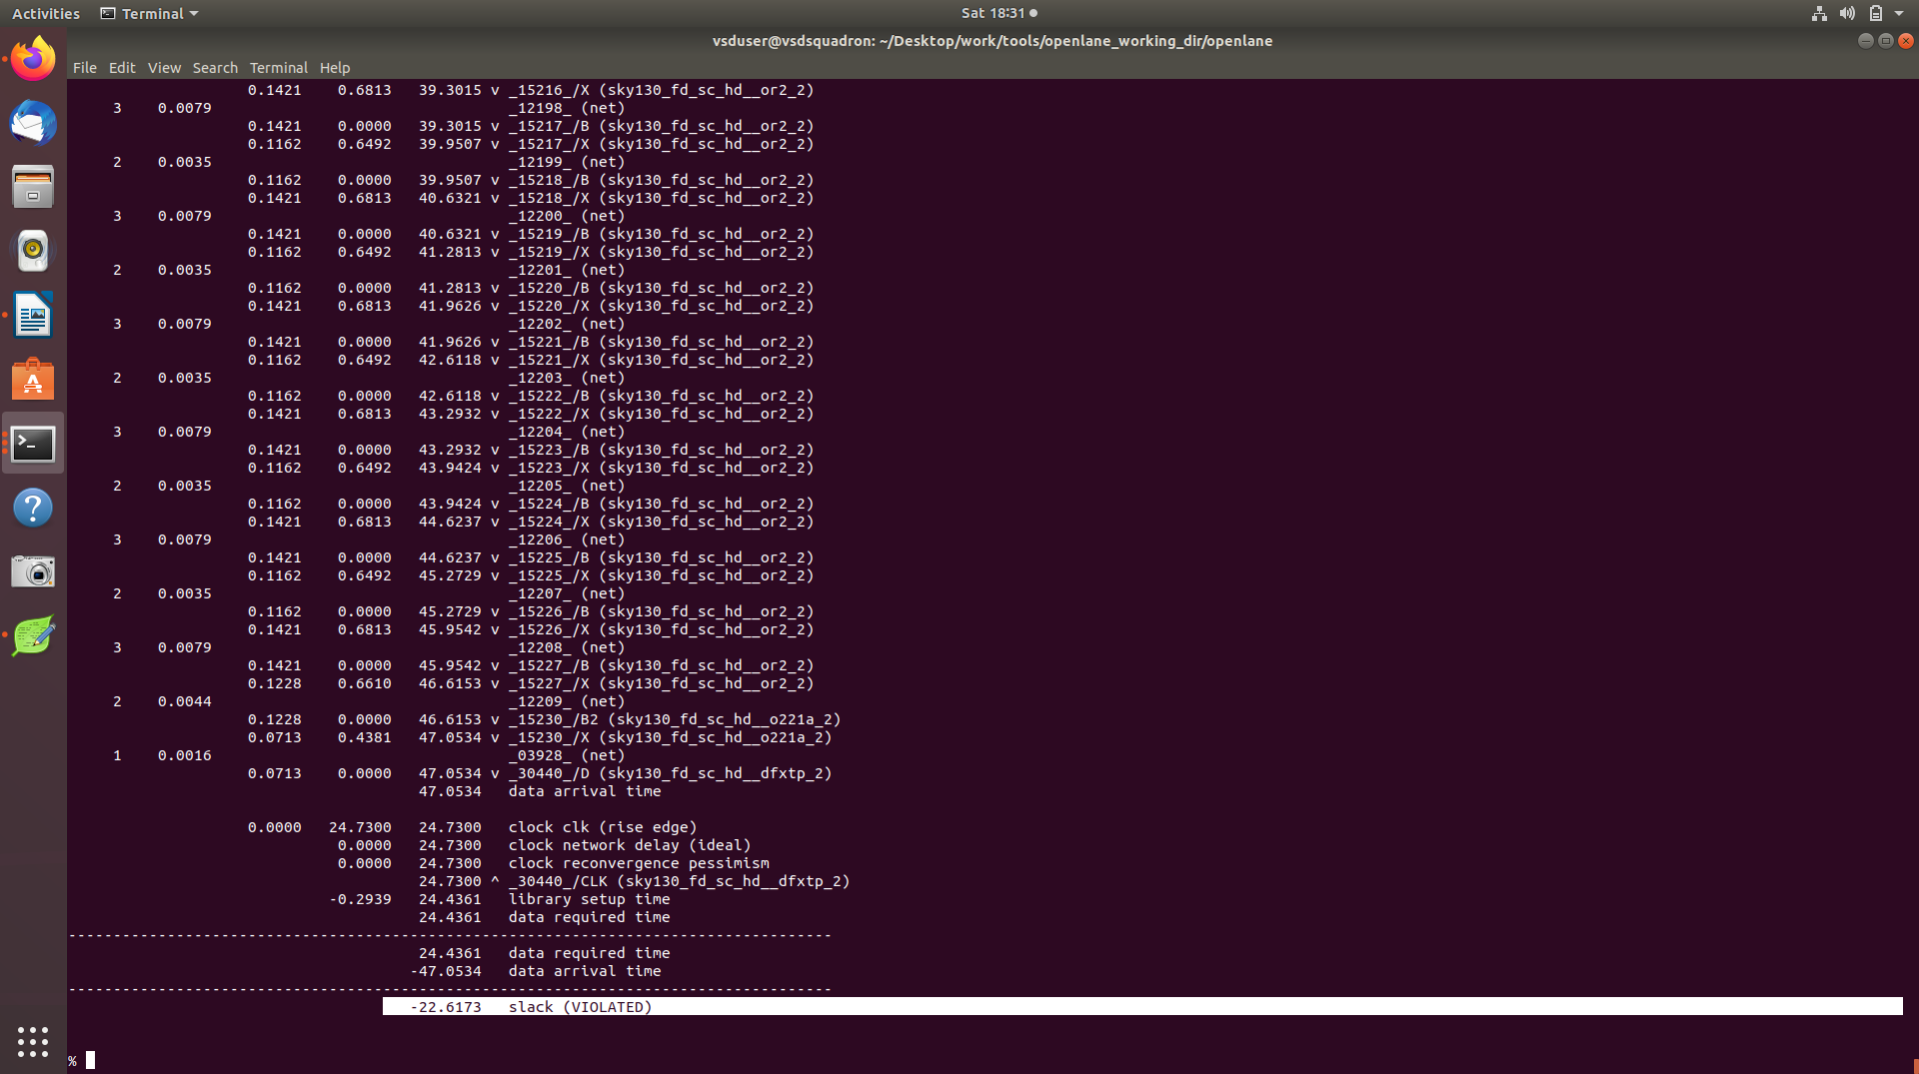
skew further reduced to -22.6173

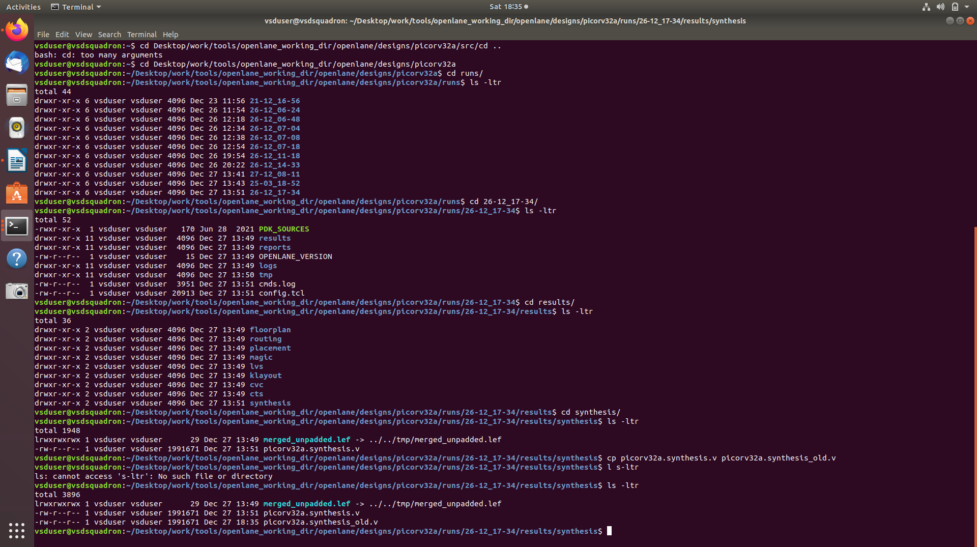
\making a copy of the netlist before chanigng that with the changed netlist after having perforrmed sta analysis using openSTA

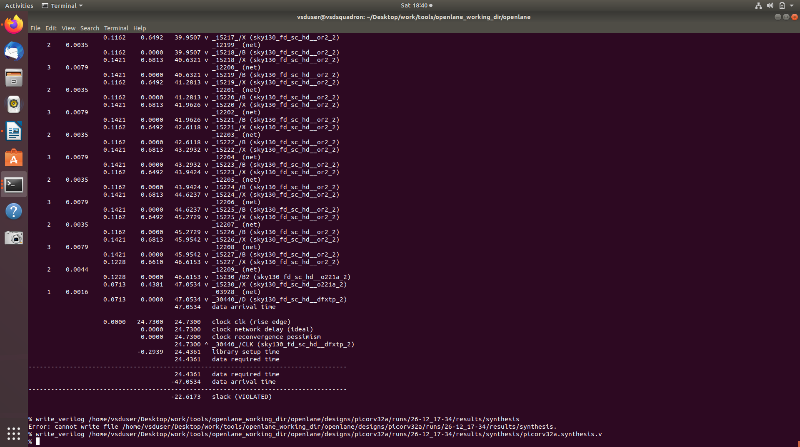
here we have used the write verilog command to write the new netlist into the synthesis file in the runs directory

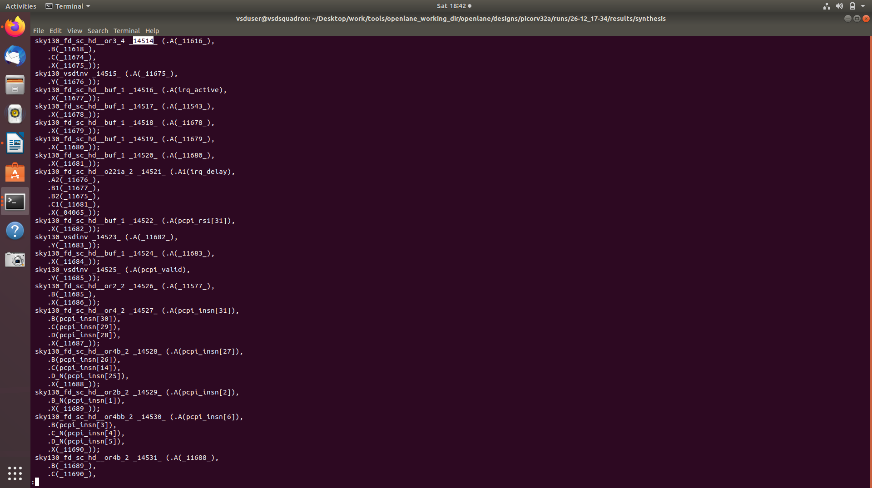
verifying that the changed instance is clearly visible in the new netlist that is created and uploaded

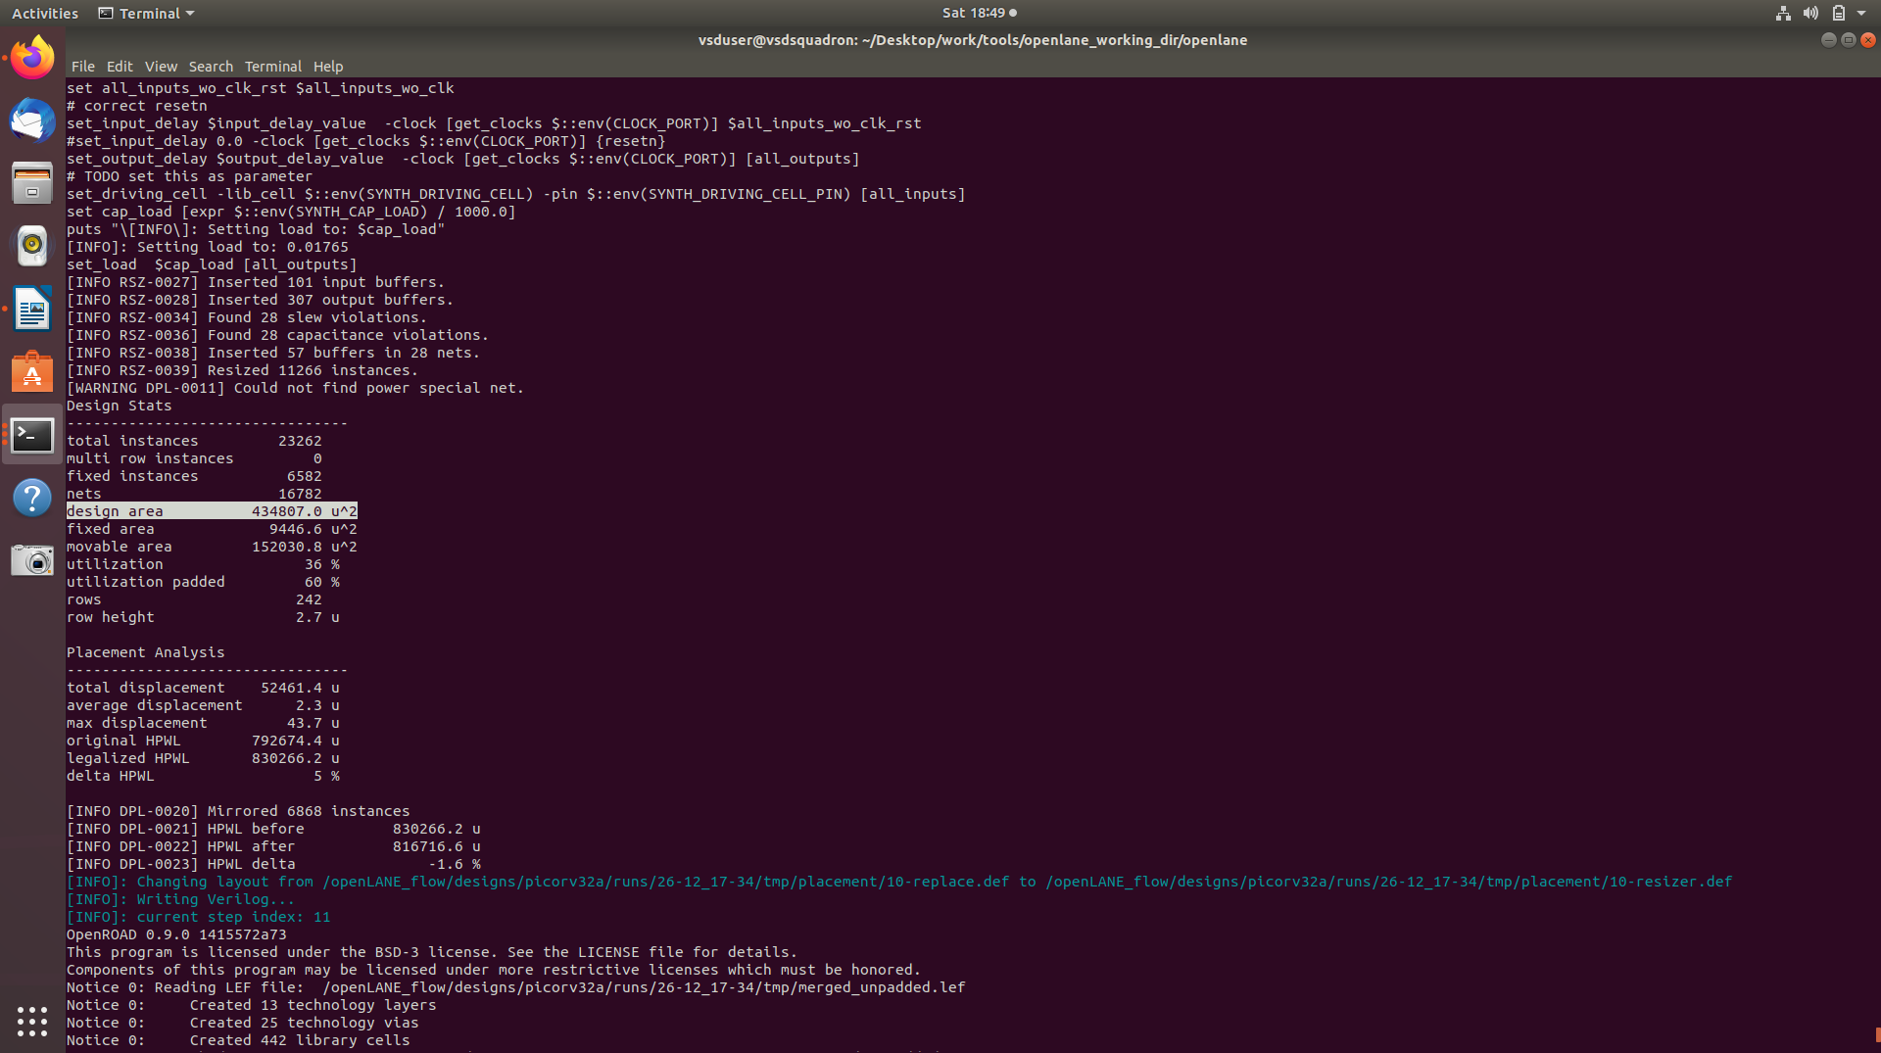
clearly seen, post placement, the new netlist lead to a decrease in slack but increase in area

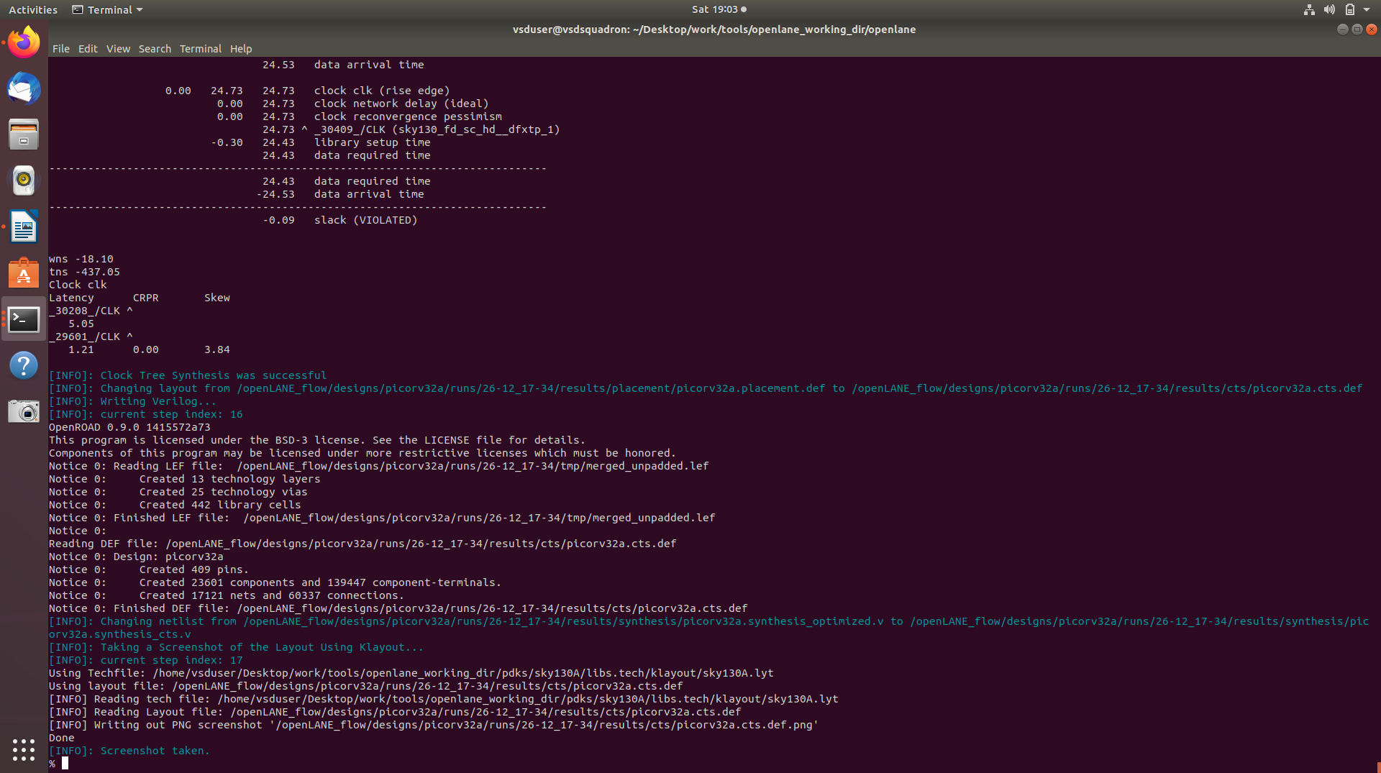
image showing successful CTS run

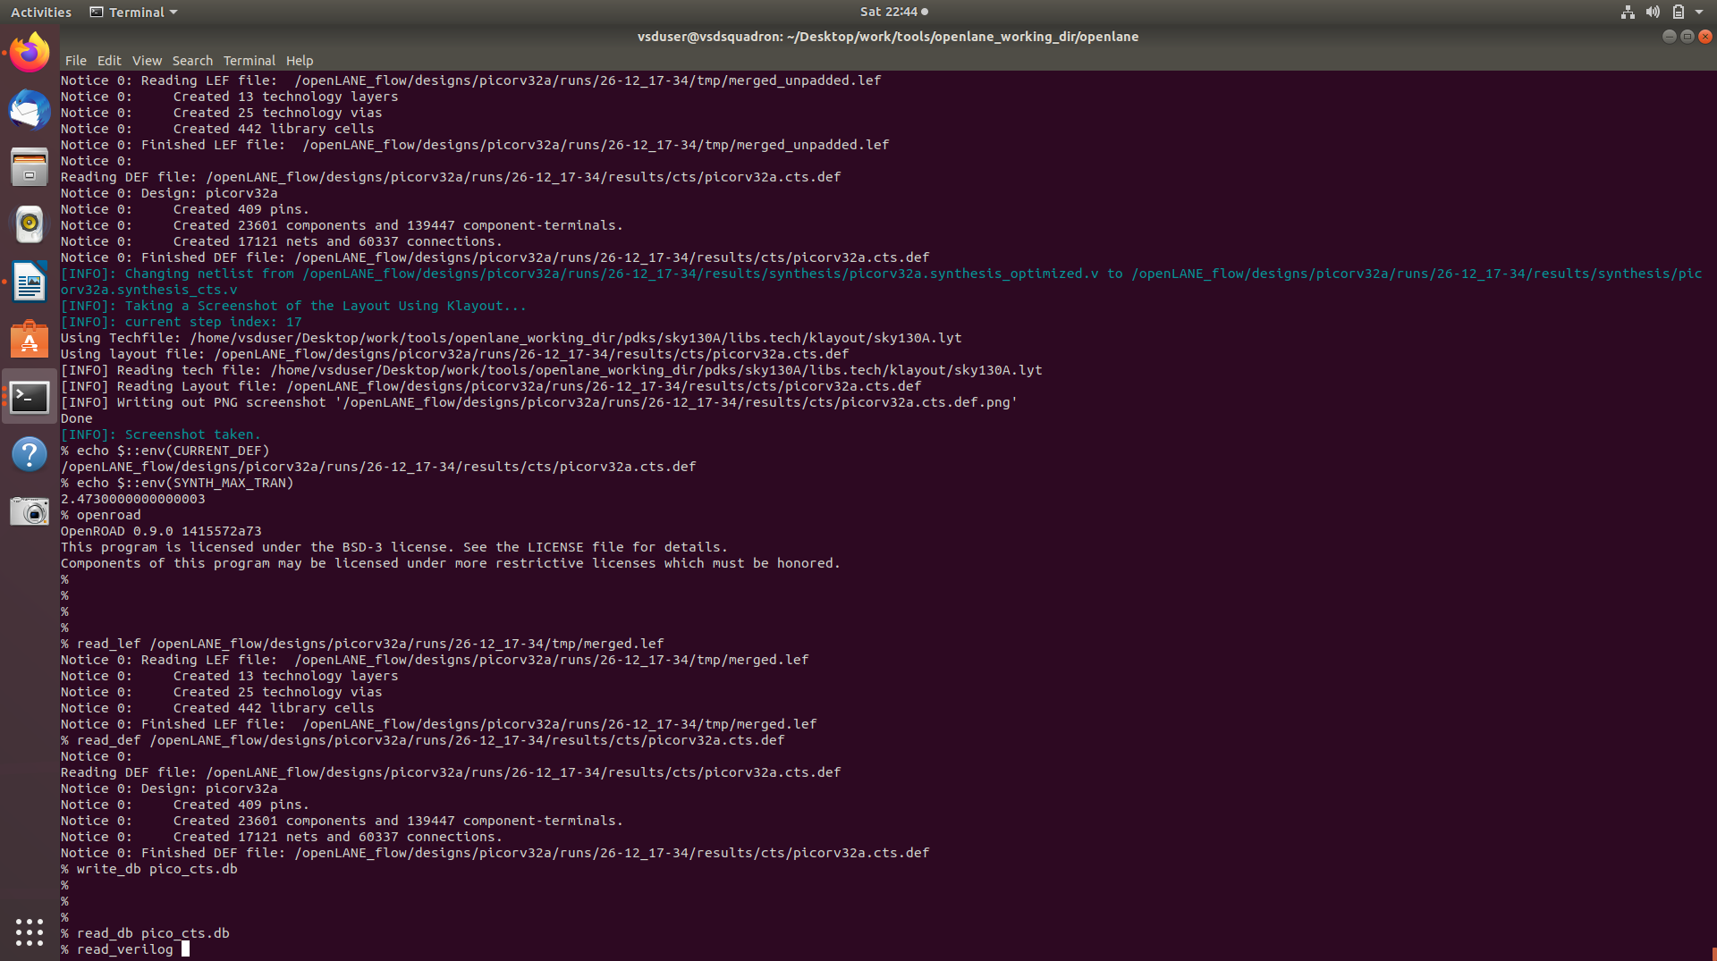
screenshot of creationg of DB for the purpose of using openSTA inside openroad

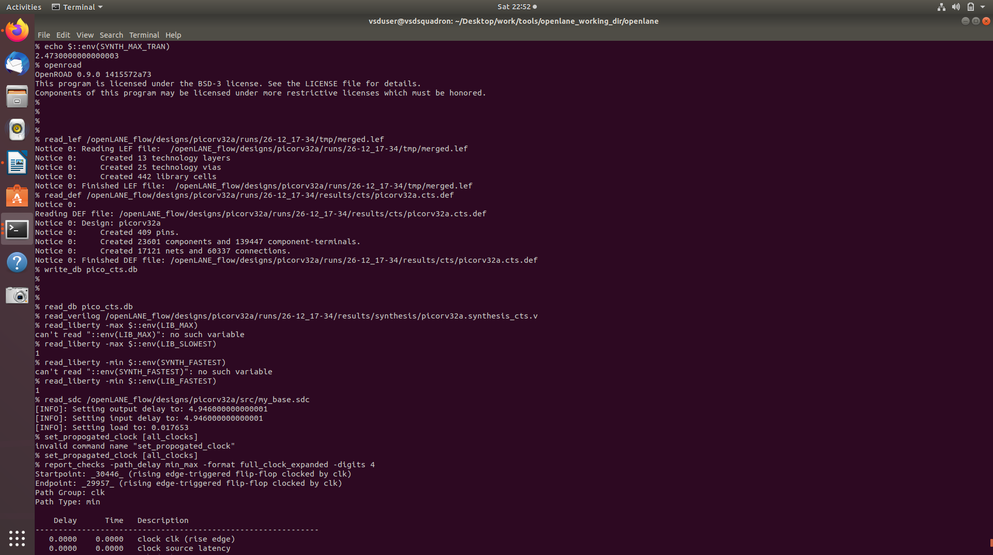

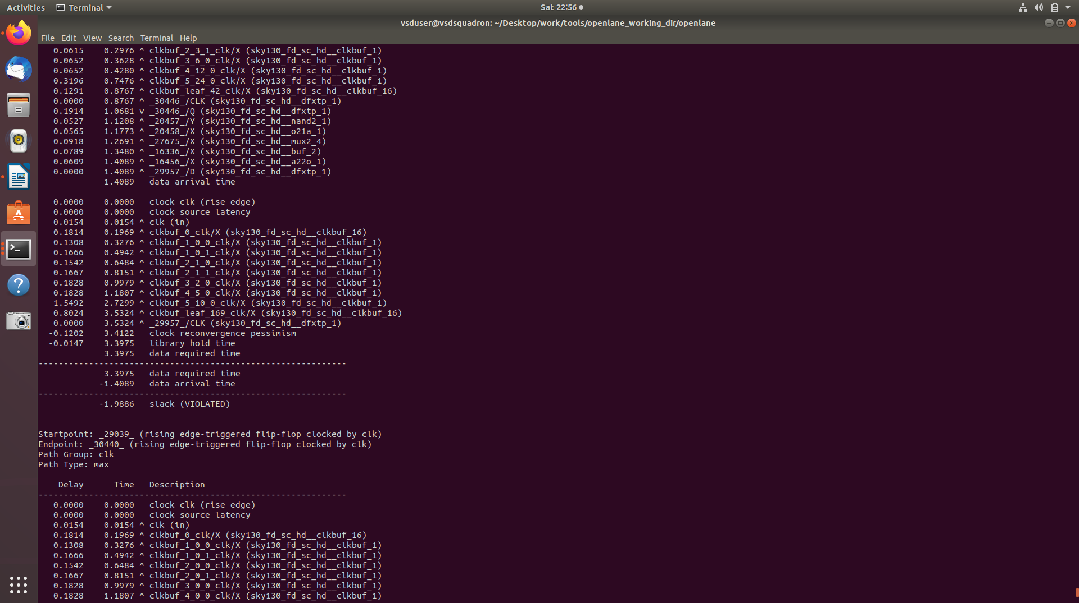
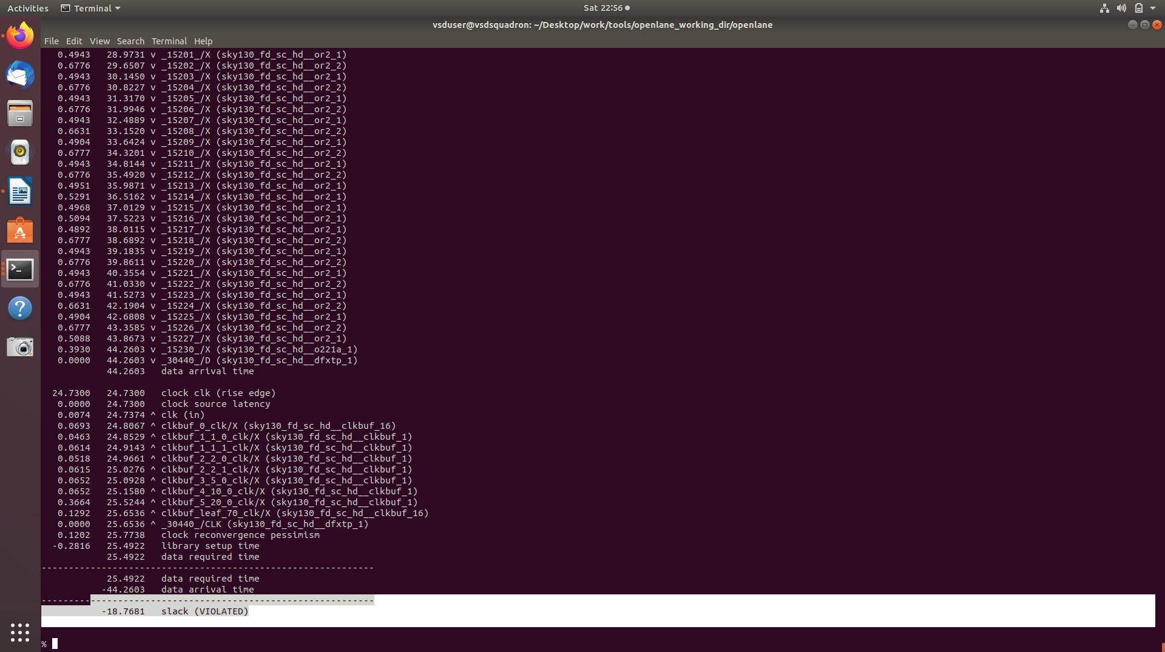
these are the images after running the cts ( report checks )

later learnt, this analysis is wronga s we have included the min max libraries for the analysis but tritonCTS has optimised for the typical corner

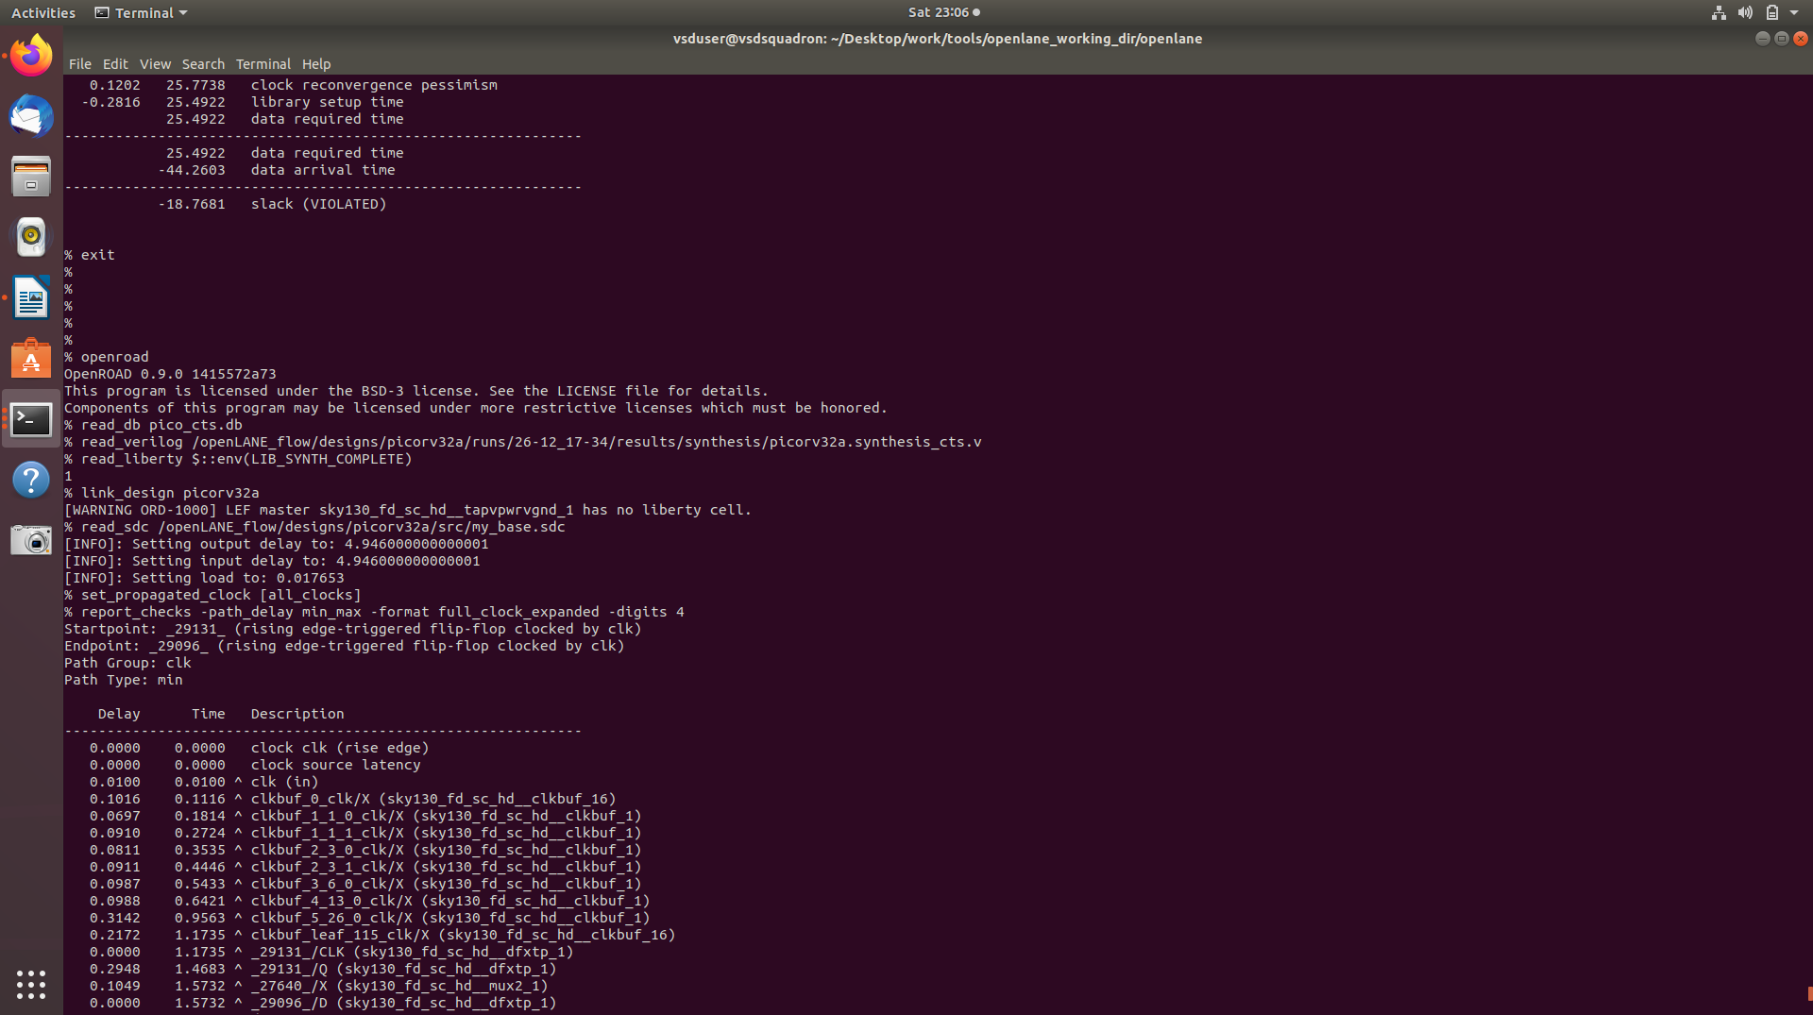
this is re run on openroad timing analysis but this time uploading only typical corner

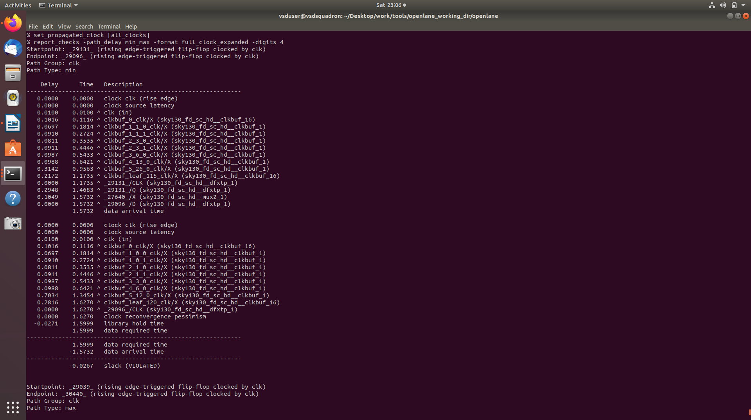
still hold violation exists

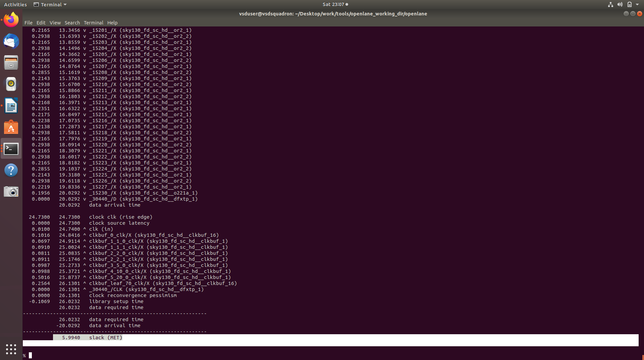
setup condition has been met, wrongly shown previously due to faulty assessment

Now we will edit the buffer list and see its effects on the timing analysis

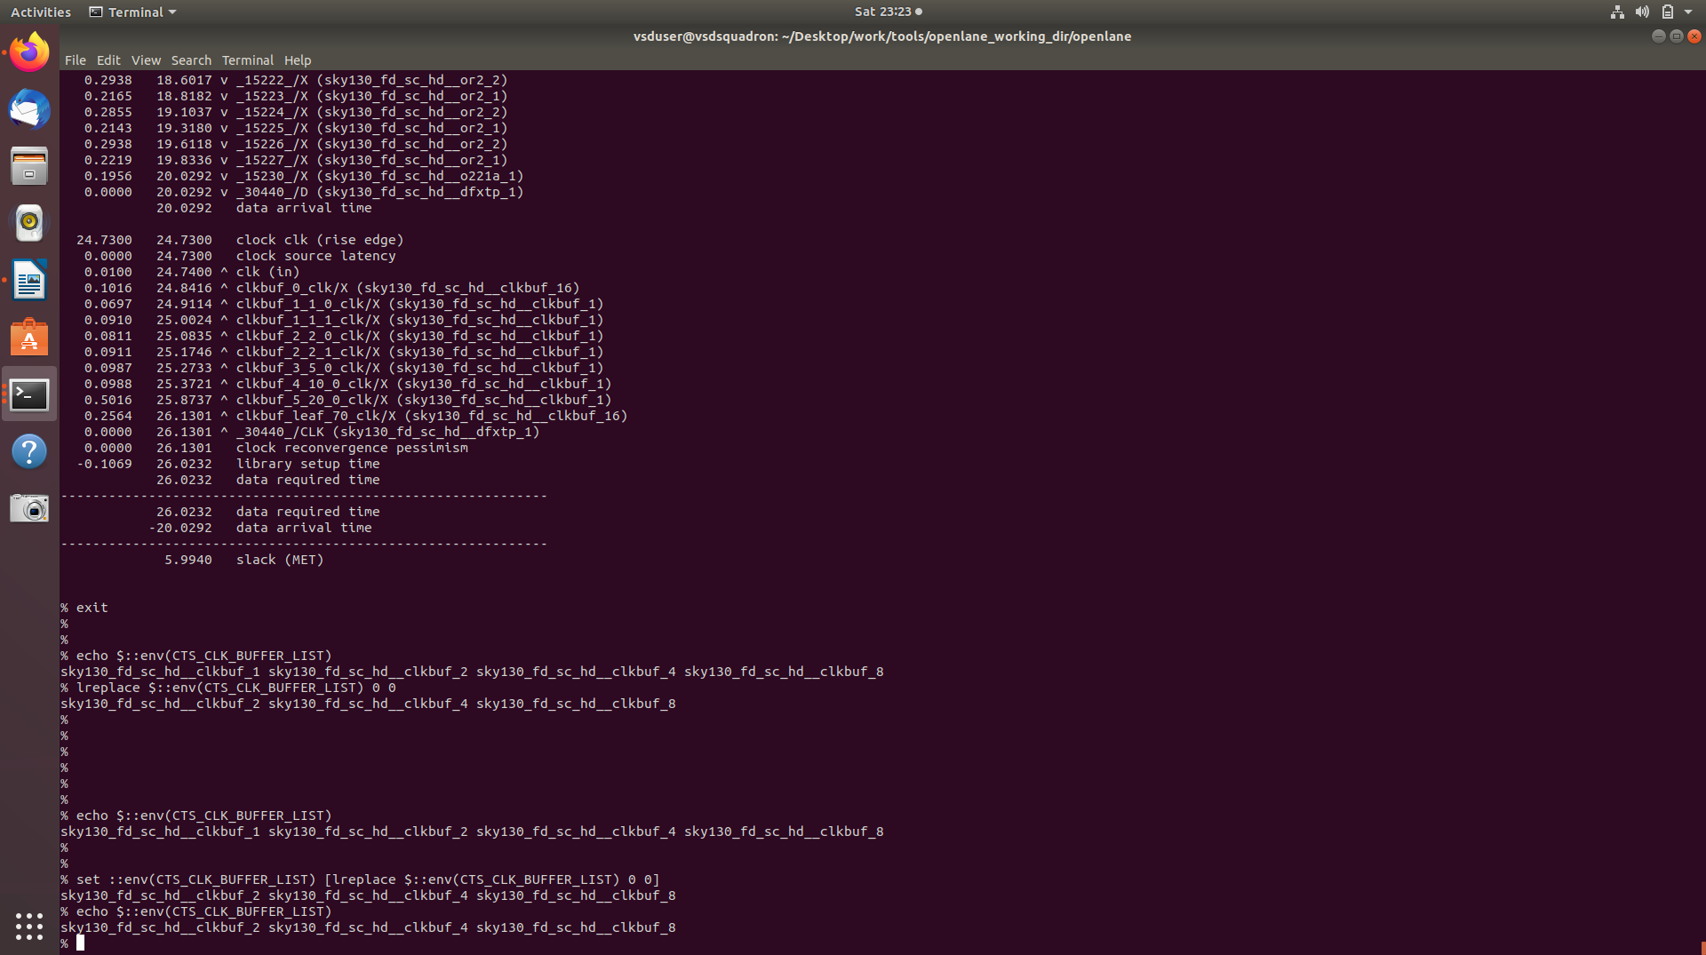
here we are changing the bufferlist

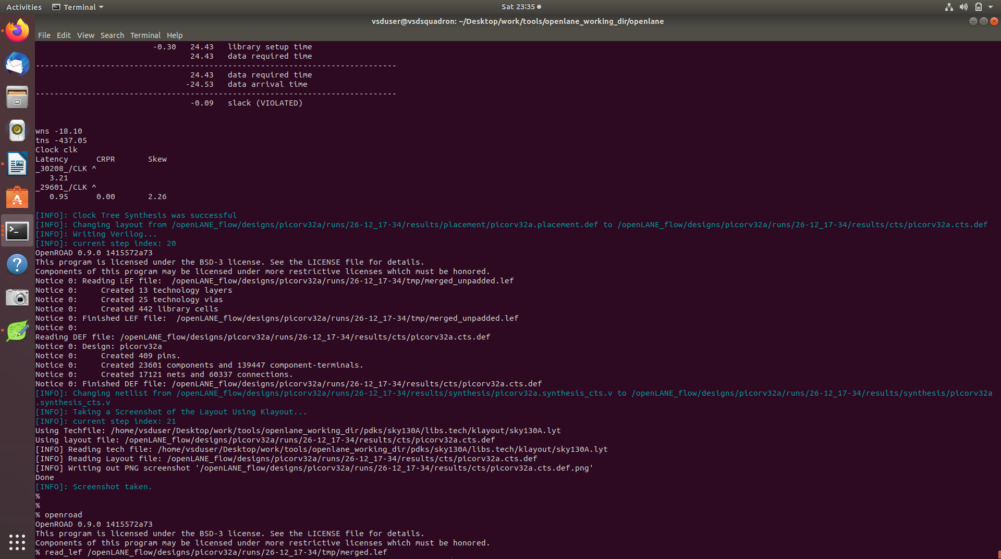
finished rerunning cts with new buffer list

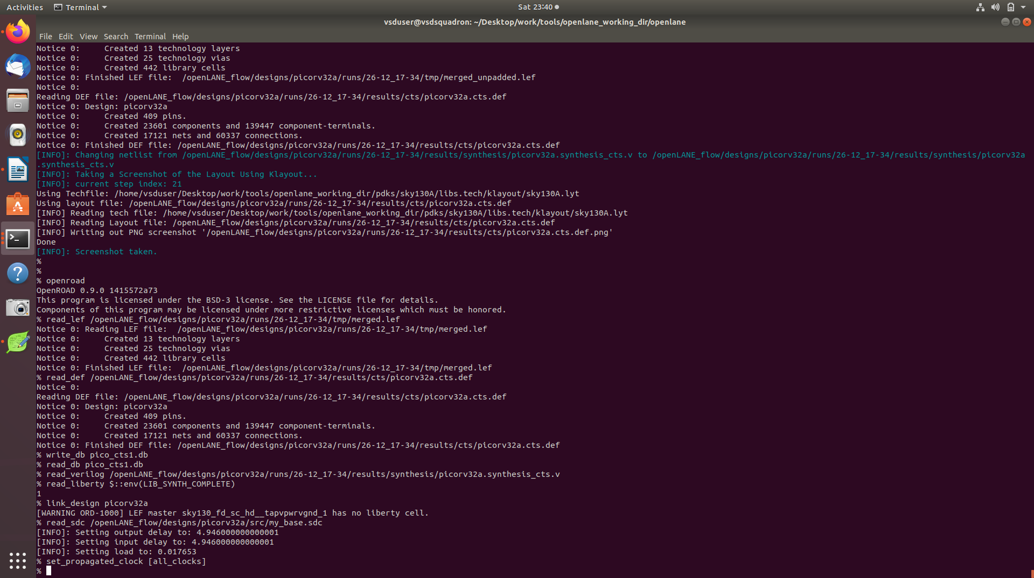
again running timing analysis in openroad

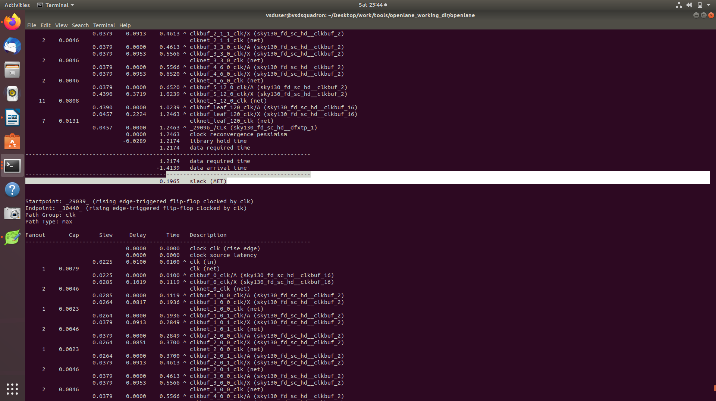
hold time violation resolved due to the use of larger buffers

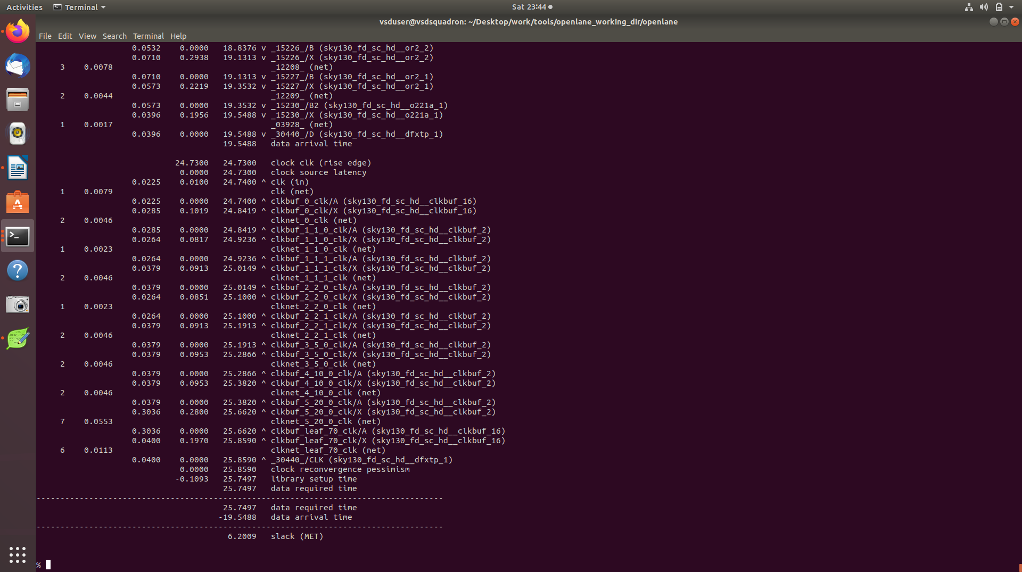
setup time margin improved with the use of larger buffers

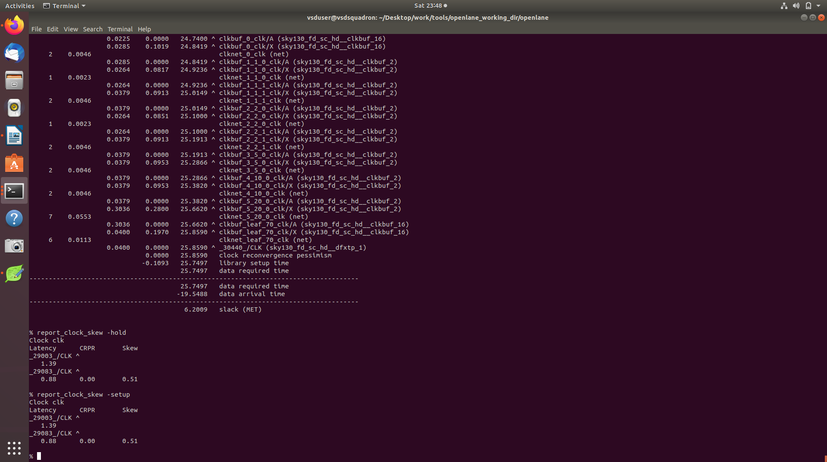
verifying the setup and hold clock skews

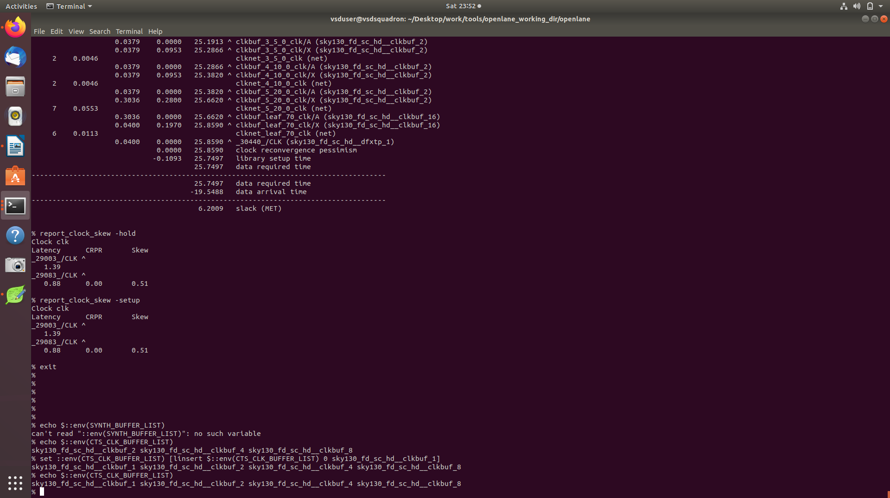
here we are reinserting the buffer1 in the buffer list

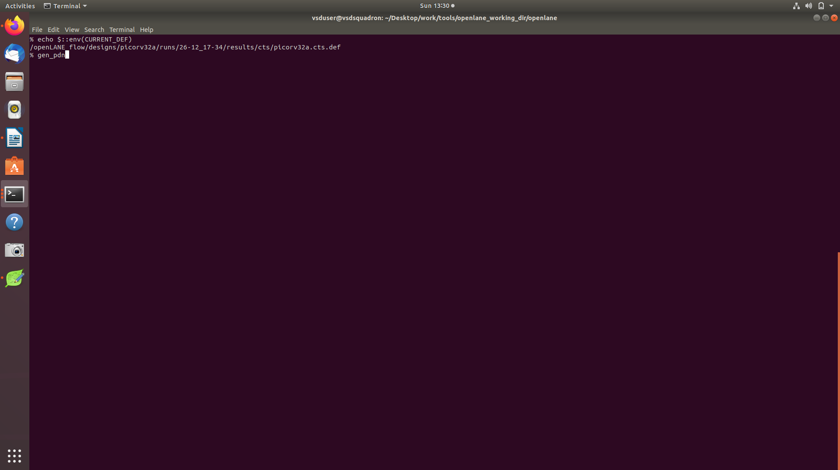
now we will run gen_pdn command to generate power distribution network

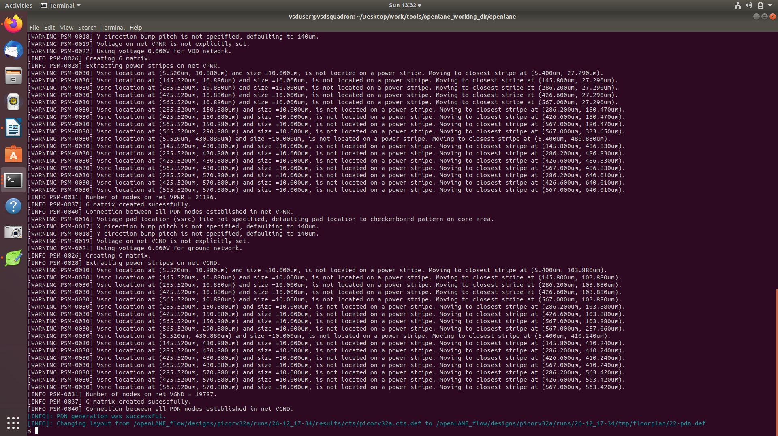
the new def file containing the layout has been created in the floorplan folder

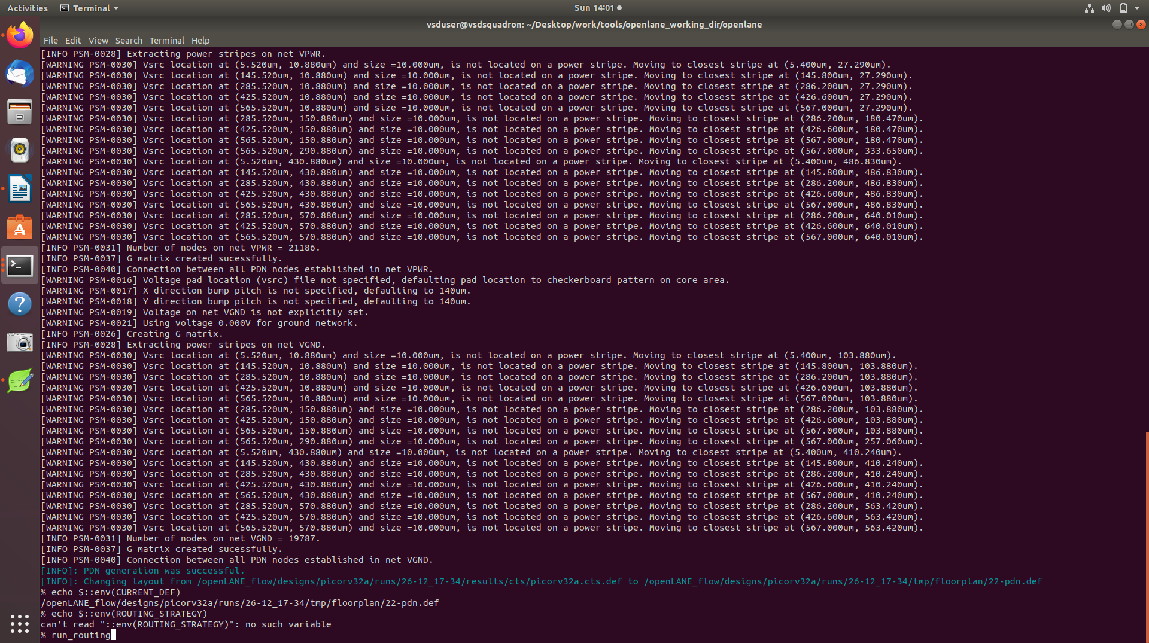
now we will start running the routing at the default configuration to save time

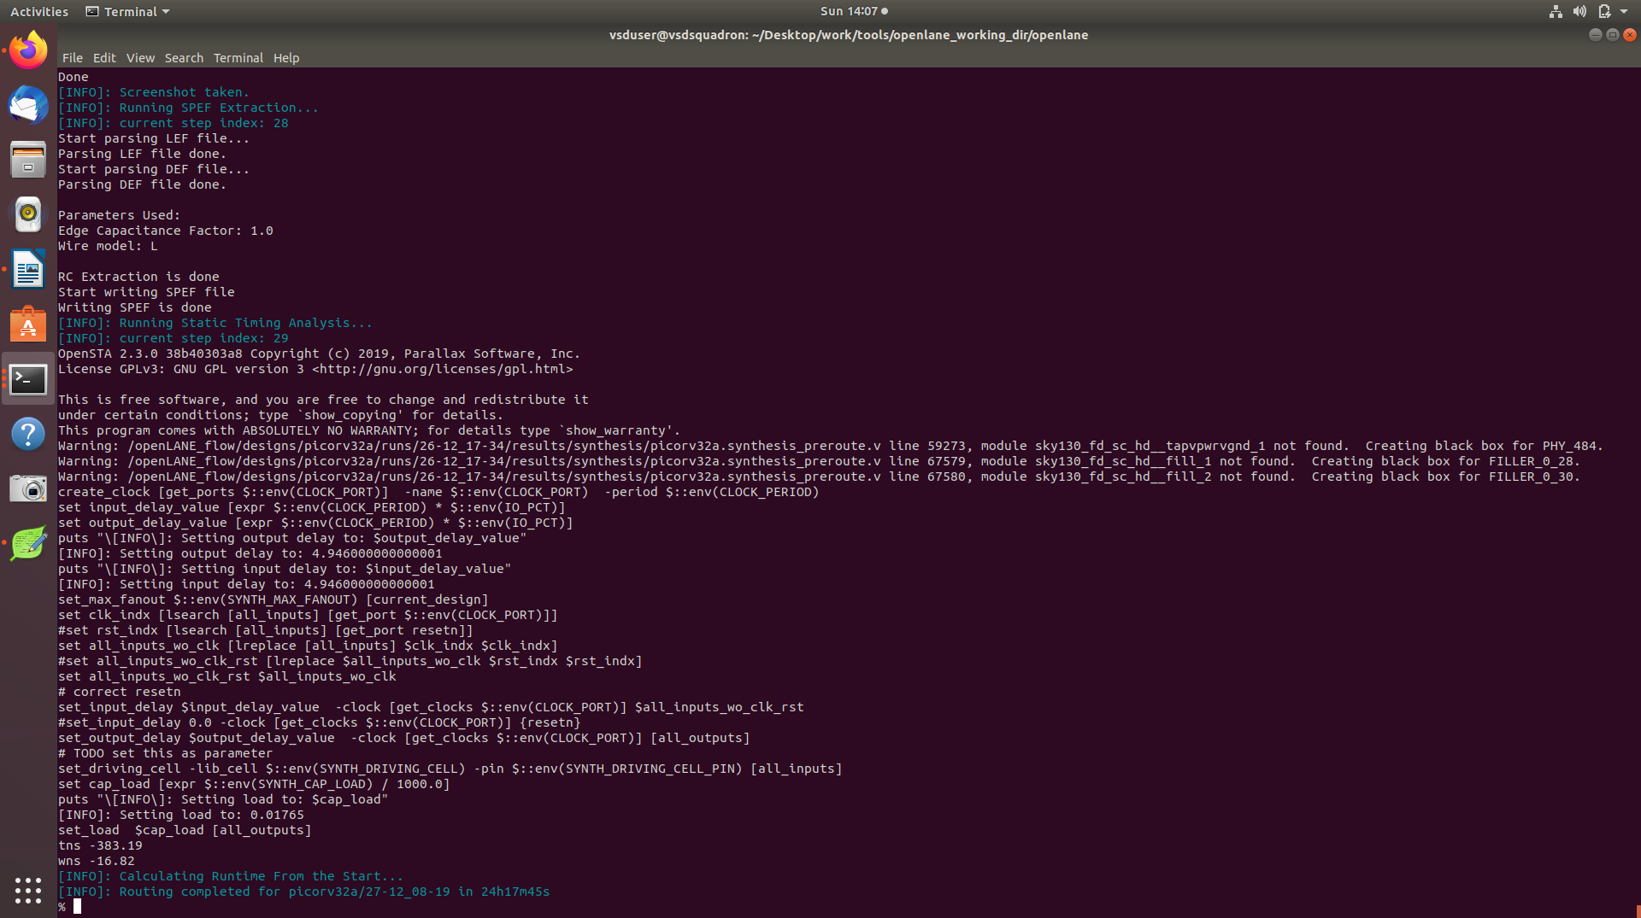
routing was finished with no DRC violations

